Mini Project Report

On

**SEE YOU CONNECT**

By

**Aditya Nalla**

**(1602-18-733-004)**

**Hemanth Reddy Tekula**

**(1602-18-733-022)**



**Under the Guidance of**

**M. Sashi Kumar**

**Department of Computer Science and Engineering**

**Vasavi College of Engineering (Autonomous)**

**Affiliated to Osmania University**

**Ibrahimbagh, Hyderabad-500031**

**2020-21**

**ACKNOWLEDGEMENT**

*We would like to express our heartfelt gratitude to M. Sashi Kumar, our project guide, for her valuable guidance and constant support, along with her capable instructions and persistent encouragement.*

*We are grateful to our Head of Department, Dr. T. Adilakshmi, for her steady support and the provision of every resource required for the completion of this project.*

*We would like to take this opportunity to thank our Principal, Dr. S. V. Ramana, as well as the management of the institute, for having designed an excellent learning atmosphere.*

*We are thankful to and fortunate enough to get constant encouragement, support and guidance which helped us in successfully completing our project work.*

**Mini Project**

**on**

**See U Connect**

**ABSTRACT**

The project is a prototype which bridges the gap between the recruiters and the students. So, we have two views for the project, one is the student view and the other is the recruiter view. In the student view, if we see every student learns some technology during his graduation, so he thinks of where to apply this knowledge and he browses for few websites and applies for few internships, but at the most times he might not receive an offer. So, this is the student view. The other view is the recruiter view. Our main focus of recruiters is College Alumni. If a college Alumni has a startup and looking for some interns he can just come to our platform and he could hire students of his requirements. Basically, it cut downs the bridge between the alumni and the student. So as this can also be looked by the recruiters during the placements. Stats tell that on an average a company spends about 3000-4000 rupees during recruitment. And also, there is much work in order to recruit the students with a wholesome resume. So, we have our recruitment logic based on the students input of their interested domains and works, based on the recruiter search we filter out the students with our logic. So, our main interest is to cut down the tedious work and also help students to find work/intern experience in startup companies which gives them a fruitful experience in the domain they work.

**INDEX**

1. See U Connect

1.1 Description 1

1.2 Student Module 1

1.3 Alumni Module 2

1.4 Admin Module 2

2. Literature Survey 3

3. Motivation 4

4. Activities

4.1 Home Portal 5

* 1. Login & signup Portal 5
  2. Admin Portal
     1. View all the latest news 5

4.3.2 View Companies & block & unblock 5

* 1. Alumni Portal
     1. Add Details 5
     2. Add Job & View Students 5
     3. View Full Profile 6
     4. Blocked Company 6
  2. Student Portal
     1. Add/ Edit Details 6
     2. View student Portfolio 6

5. System Requirement Specification

5.1 Software Specifications 7

5.2 Hardware specifications 7

6. System Design

* 1. Database Design 8

7. Pseudo Algorithm/Implementation/Code

7.1 Companies at block and unblock 9

7.2 Admin block and unblock Companies 10

7.3 Create User 10

7.4 Login User 11

7.5 Authentication for Session 11

7.6 Endpoints for every Query 12

7.7 Auth Context of See U Connect 18

7.8 Business Logic of See U Connect 19

7.9 Git hub Repository of See U Connect 20

8. Results/ Screenshots

* 1. Home Page of See U Connect 21
  2. Admin Module 22
  3. Alumni Module 24
  4. Student Module 30

9. Conclusion and Future Work 44

10. References 45

**LIST OF FIGURES**

Fig 6.1 : Database design 8

Fig 8.1.1 : Carousel of Home Page 21

Fig 8.1.2 : About See U Connect & Latest News 21

Fig 8.1.3 : Footer of See U Connect 22

Fig 8.2.1 : Admin Authentication 22

Fig 8.2.2 : Latest news added by Admin 23

Fig 8.2.3 : Latest news added successfully 23

Fig 8.2.4 : Companies at hire & at block controlled by Admin 24

Fig 8.3.1 : Partition for Alumni & Student 24

Fig 8.3.2 : Sign Up page for Alumni 25

Fig 8.3.3 : Login page for Alumni 25

Fig 8.3.4 : Profile page for Alumni 26

Fig 8.3.5 : Edit Alumni Details Page 26

Fig 8.3.6 : If Company is in block list 27

Fig 8.3.7 : If Company is at Hiring 27

Fig 8.3.8 : list of people according to requirements of Alumni 28

Fig 8.3.9 : Student profile Courses & Skills 28

Fig 8.3.10 : Student profile Experience & Projects 29

Fig 8.3.11 : Offer Letter for Student 29

Fig 8.4.1 : Sign Up for Student 30

Fig 8.4.2 : Sign up Failure 30

Fig 8.4.3 : Login page for Student 31

Fig 8.4.4 : Login Failure 31

Fig 8.4.5 : Profile page of Student1 32

Fig 8.4.6 : Personal details edit page for Student 32

Fig 8.4.7 : Secondary Education 33

Fig 8.4.8 : Senior Secondary Education 33

Fig 8.4.9 : Graduation details 34

Fig 8.4.10 : Add Projects 34

Fig 8.4.11 : Project added successfully 35

Fig 8.4.12 : Add Skill 35

Fig 8.4.13 : Add Experience 36

Fig 8.4.14 : Add Reach outs 36

Fig 8.4.15 : Add Achievements 37

Fig 8.4.16 : Add Languages known to Student 37

Fig 8.4.17 : Add Courses done by Student 38

Fig 8.4.18 : Address of Student 38

Fig 8.4.19 : Personal Details of Student 39

Fig 8.4.20 : Skills of Student 39

Fig 8.4.21 : Languages Known for Student 40

Fig 8.4.22 : Education Details of Student 40

Fig 8.4.23 : Contact Details of Student 41

Fig 8.4.24 : Work Experience of Student 41

Fig 8.4.25 : Courses done by Student 42

Fig 8.4.26 : Projects done by Student 42

Fig 8.4.27 : Awards won by Student 43

1. **See U Connect**

**1.1 Description**

The project is a prototype which bridges the gap between the recruiters and the students. So, we have two views for the project, one is the student view and the other is the recruiter view. In the student view, if we see every student learns some technology during his graduation, so he thinks of where to apply this knowledge and he browses for few websites and applies for few internships, but at the most times he might not receive an offer. So, this is the student view. The other view is the recruiter view. Our main focus of recruiters is College Alumni. If a college Alumni has a startup and looking for some interns he can just come to our platform and he could hire students of his requirements. Basically, it cut downs the bridge between the alumni and the student. So as this can also be looked by the recruiters during the placements. Stats tell that on an average a company spends about 3000-4000 rupees during recruitment. And also, there is much work in order to recruit the students with a wholesome resume. So, we have our recruitment logic based on the students input of their interested domains and works, based on the recruiter search we filter out the students with our logic. So, our main interest is to cut down the tedious work and also help students to find work/intern experience in startup companies which gives them a fruitful experience in the domain they work.

**1.2 Student Module**

In the first phase of our project, the student needs to signup with their gmail account and when he logins he can fill, edit information of the experiences he had, courses, projects, skills he has/done. He can add his personal information too. After adding the information, we provide the student with a portfolio kind for him which he can use in his career. He can look out for the latest recruitments that has been going in the website at the latest news. Once his graduation completes his status of student changes to Alumni automatically. In the second phase we are planning to have login same as that of college credentials and taking preliminary information about a student from college so as to ease the process of filling information. So as this project is restricted from one college to one college (In the first phase trail with one college) the security issues don’t raise.

**1.3 Alumni Module**

The alumni can signup with google in the first phase and he can fill the startup or the company details in which he work, now he have access to look out for the students base don his requirements. He can also view their full profile and also there’s option of sending mail if he wants to get in touch with the student. Alumni/Recruiter can add the startup details and recruitment post which will be added to the latest news where everyone can see the post.

**1.4 Admin Module**

For each college one admin account will be given so as to ensure the security of the student’s data and also to ensure the legality of the recruiting companies. An admin can block the company if he feels the company to be illegal/giving false posts. So, admin has full control over the recruitment point of view.

1. **Literature Survey**

As our project has two phases-the recruitment phase and the student phase;we have looked at researches on both scenarios.  
<https://www.researchgate.net/publication/228254240_The_Use_of_Technologies_in_the_Recruiting_Screening_and_Selection_Processes_for_Job_Candidates>  
The above research gives us the survey on technology used in recruiting and selection in order to determine (a) what technologies are being used in HR, (b) HR managers' goals for using these technologies, (c) the extent to which these goals are being met, and (d) what organizational factors (e.g., organizational image) lead to adopting these technologies. We conclude that the use of HR technologies is in a state of flux with most organizations continuing to use a mix of traditional and technology-based HR methods.  
  
<https://www.tandfonline.com/doi/abs/10.1080/09593960903498342?scroll=top&needAccess=true&journalCode=rirr20>  
For decades,companies have agreed that internships play a vital role in students' retail education. Overall, the perceived value of internships/internship programmes and the attitude towards them have remained fairly stable and positive. However, the role of internships, their structure and the way they are administered have changed. After reviewing relevant literature, the above research identified five dimensions as major trends/changes regarding internships or internship programmes over the past 20 years: 1) internships: the new recruiting tool; 2) increased endorsement of internships by retailers and educators; 3) paid vs. non-paid internships: a legal issue?; 4) structure of internship programmes revamped; and 5) socialization of interns: creating a bond. Each dimension is discussed in detail and practical implications for retail interns, employers and educators are presented.

1. **Motivation**

As we see many students are learning great technologies and taking up great courses but all it comes to waste if they don’t know where to apply, if he/she does get some experience in the domain he/she learnt it could be helpful in getting the inside edge of the technology. And also, on an average a recruiter spends about 3000 rupees during the recruitment process, cutting down to 0 was the main motive. The startups play an important role in the country’s GDP, so If the recruiters are the alumni of a particular college, they can hire interns with ease by this platform. It helps both the recruiter and the student. The main motive is the student need to get great experience of work in the filed of the domain they are interested. Startups are the place where it gives a intern fruitful experience and knowledge too.

1. **Activities**
   1. **Home Portal**

This is the website’s home page where one can find the information regarding the platform and they can also see the latest news that are going in the college under recruitment area, and also the details of the website creators(we).

* 1. **Login & signup Portal**

Here we have the three login & signup portals, the alumni and student has signup in which they can sign up using their Gmail account, if the alumni try to login through student the access will be denied and vice versa and also the admin has direct login through pin which will be given by the portal admin’s.

* 1. **Admin Portal**
     1. **View all the latest news**

In this screen the admin can look at all the latest news and also he can add any announcements here and also, he can delete the latest news which are not necessary

* + 1. **View Companies & block & unblock**

In this screen the admin can look at all the companies and their recruitment offer, if the admin feels the company is not legal and they are spreading false statements over the website the admin can block the company, and the company in order to get unblocked need to contact the admin for further communication.

* 1. **Alumni Portal**
     1. **Add Details**

In this screen the alumni can add his information and also the company details. So that the admin can look at the company details.

* + 1. **Add Job & View Students**

In this screen the alumni can add job which gets added to the latest news and also, he can view students based on the requirement, i.e. he can add skills where we filter the students based on the skills percentage and also other things in the criterion. We have our own code logic in order to scrap the students to get best out of the best.

* + 1. **View Full Profile**

In this screen the alumni can view the student’s profile and also there will be an option in order to send a direct mail to the student if the alumni is interested in recruiting.

* + 1. **Blocked Company**

If the company status gets blocked the alumni cant get the students data and also, he has to get in contact to admin in order to get unblocked.

* 1. **Student Portal**
     1. **Add/ Edit Details**

When the user clicks the add/edit option in the side bar it gets landed to other area where the user can fill/edit the details like personal information, skills, courses, languages, address, education details, achievements, positions/any experiences.

* + 1. **View student Portfolio**

When the user adds the details, with the information given by the student we provide a portfolio kind web view where student can find all the details he filled. The side nav bar of this view contains information on achievements, courses, personal information, contact, education etc.

1. **System Requirement Specification**

**5.1 Software Specifications**

Database: Mongodb

Backend: Express Graphql

Frontend (Web Technologies): React framework and Reactbootstrap

Server Side: Graphql

Hardware specification

Processor : i5 Core Processor

Clock speed : 2.5GHz

Monitor : 1024 * 768 Resolution Color

Keyboard : QWERTY

RAM : 1 GB

Input Output Console for interaction

**5.2 Hardware specifications**

Processor: Core i3 Processor

Clock speed: 2.5GHz

Monitor: 1920* 1080 Resolution Color

Browser: Chrome, Opera, Internet Explorer etc.

Keyboard: QWERTY

RAM: 8 GB

1. **System Design**
   1. **Database Design**

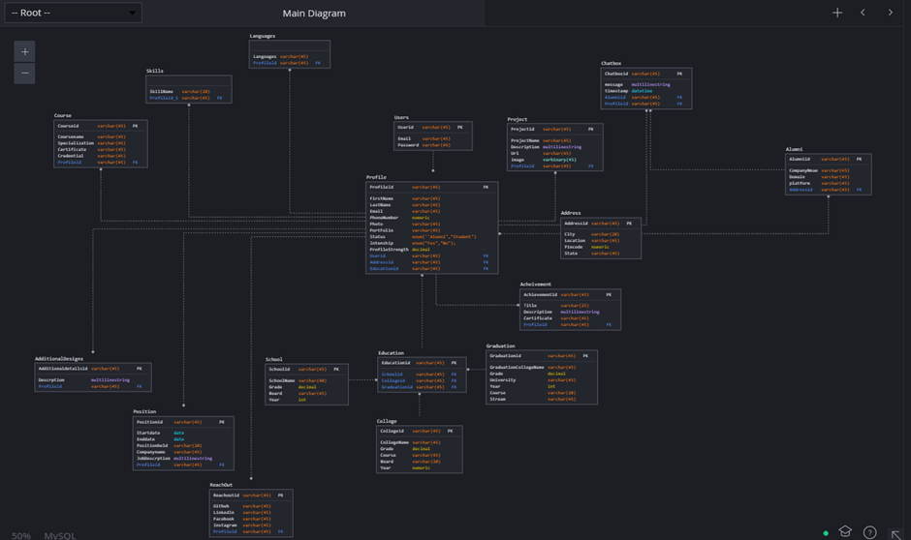

6.1 Database design

1. **Pseudo Algorithm/Implementation/Code**
   1. **Companies at block and unblock**

const requestBody = {

            query: `

            query{

                companies{

                  _id

                  companyName

                  name

                  companyWebsite

                  blocked

                }

              }

            `

        };

      fetch('http://localhost:4000/graphql', {

              method: 'POST',

              body: JSON.stringify(requestBody),

              headers: {

                  'Content-Type': 'application/json'

              }

          }).then(res => {

              if(res.status!== 200 && res.status!== 201){

                  throw new Error('Failed!');

              }

              return res.json();

          })

          .then(resData => {

            this.setState({companies: resData.data.companies});

            this.state.companies.map(item =>{

                if(item.blocked){

                    let list = [...this.state.blocked];

                    list.push(item)

                    this.setState({

                        blocked: list

                    });

                }

                else{

                    let list = [...this.state.unBlocked];

                    list.push(item)

                    this.setState({

                        unBlocked: list

                    });

                }

            });

          })

          .catch(err => {

              console.log(err);

          });

**7.2 Admin block and unblock Companies**

CompanyUpdate: async args =>{

        try{

            const alumniUser = await Alumni.findById(args.alumniId);

            alumniUser.blocked = !alumniUser.blocked

            await alumniUser.save();

            return { ...alumniUser._doc, _id: alumniUser._doc._id.toString(),

                users: userInfo.bind(this,alumniUser._doc.userId)

            };

        }

        catch (err){

            throw err;

        }

    }

* 1. **Create User**

CreateUser: async args => {

        try {

            const user = await User.findOne({ email: args.userInput.email });

            //to find user already exist or not

            if (user) {

                throw new Error('user exist already');

            }

            const hashedPassword = await bcrypt.hash(args.userInput.password, 15);

            const user_1 = new User({

                name: args.userInput.name,

                email: args.userInput.email,

                password: hashedPassword,

                userType: args.userInput.userType,

                profileId: null,

                alumniId: null

            });

            const result = await user_1.save();

            return {...result._doc, _id: result._doc._id.toString(),

                profile: profileInfo.bind(this,result._doc.profileId),

                alumni: alumniInfo.bind(this,result._doc.alumniId)

            };

        } catch (err) {

            throw err;

        }

    }

* 1. **Login User**

login: async ({email,password}) => {

        const user = await User.findOne({email: email});

        if(!user)

        {

            throw new Error('User does not exist');

        }

        const isEqual = await bcrypt.compare(password, user.password);

        if(!isEqual)

        {

            throw new Error('password is incorrect');

        }

        const token = jwt.sign({userId: user.id, profileId: user.profileId}, 'sucSuperPrivateKey', {expiresIn: '1h'});

        return{ userId: user.id, token: token,userType: user.userType, tokenExpiration: 1};

    }

* 1. **Authentication for Session**

const jwt = require('jsonwebtoken');

module.exports = (req, res, next) => {

    const authHeader = req.get('Authorization');

    if(!authHeader){

        req.isAuth = false;

        return next();

    }

    const token = authHeader.split(' ')[1];

    if(!token || token === ''){

        req.isAuth = false;

        return next();

    }

    let decodedToken;

    try{

    decodedToken = jwt.verify(token, 'sucSuperPrivateKey');

    }

    catch( err ){

        req.isAuth = false;

        return next();

    }

    if(!decodedToken){

        req.isAuth = false;

        return next();

    }

    req.isAuth = true;

    req.userId = decodedToken.userId;

    req.userType = decodedToken.userType;

    req.profileId = decodedToken.profileId;

    next();

};

* 1. **Endpoints for every Query**

const Profile = require('../../models/profile');

const Achievement = require('../../models/achievement');

const AdditionalDetails = require('../../models/additionalDetails');

const Address = require('../../models/address');

const Course = require('../../models/course');

const Language = require('../../models/language');

const Position = require('../../models/position');

const Project = require('../../models/project');

const ReachOut = require('../../models/reachOut');

const Skill = require('../../models/skill');

const School = require('../../models/school');

const College = require('../../models/college');

const Graduation = require('../../models/graduation');

const Education = require('../../models/education');

const Alumni = require('../../models/alumni');

const User = require('../../models/users');

const userInfo = async userId =>{

    try{

        const user = await User.findById(userId);

        return {...user._doc, _id: user._doc._id.toString(),

            profile: profileInfo.bind(this,user._doc.profileId),

            alumni: alumniInfo.bind(this,user._doc.alumniId)

        };

    }

    catch ( err ){

        throw err;

    }

}

const alumniInfo = async alumniId => {

    try {

        const result = await Alumni.findById(alumniId);

        return { ...result._doc, _id: result._doc._id.toString(),

            users: userInfo.bind(this,result._doc.userId)

        };

    } catch (err) {

        throw err;

    }

};

const profileInfo = async profileId => {

    try {

        const result = await Profile.findById(profileId);

        return { ...result._doc, _id: result._doc._id.toString(),

            addresses: addressInfo.bind(this,result._doc._id.toString()),

            skills: skillInfo.bind(this,result._doc._id.toString()),

            positions: positionInfo.bind(this,result._doc._id.toString()),

            projects: projectInfo.bind(this,result._doc._id.toString()),

            courses: courseInfo.bind(this,result._doc._id.toString()),

            languages: languageInfo.bind(this,result._doc._id.toString()),

            achievements: achievementInfo.bind(this,result._doc._id.toString()),

            detailsAdditional: additionalInfo.bind(this,result._doc._id.toString()),

            reachOuts: reachOutInfo.bind(this,result._doc._id.toString()),

            education: educationInfo.bind(this,result._doc._id.toString()),

            users: userInfo.bind(this,result._doc.userId)

        };

    } catch (err) {

        throw err;

    }

};

const achievementInfo = async profileId => {

    try {

        const jobsDone = await Achievement.find({profileId: {$in: profileId}});

        return jobsDone.map(result => {

            return { ...result._doc, _id: result._doc._id.toString(),

                profile: profileInfo.bind(this,result._doc.profileId)

        };

        });

    } catch (err) {

        throw err;

    }

};

const additionalInfo = async profileId => {

    try {

        const additional = await AdditionalDetails.find({profileId: {$in: profileId}});

        return additional.map(result => {

            return { ...result._doc, _id: result._doc._id.toString(),

                profile: profileInfo.bind(this,result._doc.profileId)

            };

        });

    } catch (err) {

        throw err;

    }

};

const addressInfo = async profileId => {

    try {

        const result = await Address.find({profileId: {$in: profileId}});

        return {...result[0]._doc, _id: result[0]._doc._id.toString(),

            profile: profileInfo.bind(this,result[0]._doc.profileId)

            };

    } catch (err) {

        throw err;

    }

};

const courseInfo = async profileId => {

    try {

        const study = await Course.find({profileId: {$in: profileId}});

        return study.map(result => {

            return { ...result._doc, _id: result._doc._id.toString(),

                profile: profileInfo.bind(this,result._doc.profileId)

            };

        });

    } catch (err) {

        throw err;

    }

};

const languageInfo = async profileId => {

    try {

        const languages = await Language.find({profileId: {$in: profileId}});

        return languages.map(result => {

            return { ...result._doc, _id: result._doc._id.toString(),

                profile: profileInfo.bind(this,result._doc.profileId)

            };

        });

    } catch (err) {

        throw err;

    }

};

const positionInfo = async profileId => {

    try {

        const stand = await Position.find({profileId: {$in: profileId}});

        return stand.map(result => {

            return { ...result._doc, _id: result._doc._id.toString(),

                profile: profileInfo.bind(this,result._doc.profileId)

            };

        });

    } catch (err) {

        throw err;

    }

};

const projectInfo = async profileId => {

    try {

        const projects = await Project.find({profileId: {$in: profileId}});

        return projects.map(result => {

            return { ...result._doc, _id: result._doc._id.toString(),

                profile: profileInfo.bind(this,result._doc.profileId)

            };

        });

    } catch (err) {

        throw err;

    }

};

const reachOutInfo = async profileId => {

    try {

        const result = await ReachOut.find({profileId: {$in: profileId}});

        return {...result[0]._doc, _id: result[0]._doc._id.toString(),

            profile: profileInfo.bind(this,result[0]._doc.profileId)

            };

    } catch (err) {

        throw err;

    }

};

const skillInfo = async profileId => {

    try {

        const skills = await Skill.find({profileId: {$in: profileId}});

        return skills.map(result => {

            return { ...result._doc, _id: result._doc._id.toString(),

                profile: profileInfo.bind(this,result._doc.profileId)

            };

        });

    } catch (err) {

        throw err;

    }

};

const infoEducation = async educationId => {

    try {

        const result = await Education.findById(educationId);

        return educationInfo(result._doc.profileId);

    } catch (err) {

        throw err;

    }

};

const schoolInfo = async schoolId => {

    try {

        const result = await School.findById(schoolId);

        return { ...result._doc, _id: result._doc._id.toString(),

            education: infoEducation.bind(this, result._doc.educationId)

        };

    } catch (err) {

        throw err;

    }

};

const collegeInfo = async collegeId => {

    try {

        const result = await College.findById(collegeId);

        return { ...result._doc, _id: result._doc._id.toString(),

            education: infoEducation.bind(this, result._doc.educationId)

        };

    } catch (err) {

        throw err;

    }

};

const graduationInfo = async graduationId => {

    try {

        const result = await Graduation.findById(graduationId);

        return { ...result._doc, _id: result._doc._id.toString(),

            education: infoEducation.bind(this, result._doc.educationId)

        };

    } catch (err) {

        throw err;

    }

};

const educationInfo = async profileId => {

    try {

        const result = await Education.find({profileId: {$in: profileId}});

        return { ...result[0]._doc, _id: result[0]._doc._id.toString(),

            school: schoolInfo.bind(this,result[0]._doc.schoolId),

            college: collegeInfo.bind(this,result[0]._doc.collegeId),

            graduation: graduationInfo.bind(this,result[0]._doc.graduationId),

            profile: profileInfo.bind(this,result[0]._doc.profileId)

         };

    } catch (err) {

        throw err;

    }

};

exports.userInfo = userInfo;

exports.alumniInfo = alumniInfo;

exports.profileInfo = profileInfo;

exports.achievementInfo = achievementInfo;

exports.additionalInfo = additionalInfo;

exports.addressInfo = addressInfo;

exports.courseInfo = courseInfo;

exports.languageInfo = languageInfo;

exports.positionInfo = positionInfo;

exports.projectInfo = projectInfo;

exports.reachOutInfo = reachOutInfo;

exports.skillInfo = skillInfo;

exports.schoolInfo = schoolInfo;

exports.collegeInfo = collegeInfo;

exports.graduationInfo = graduationInfo;

exports.educationInfo = educationInfo;

exports.infoEducation = infoEducation;

* 1. **Auth Context of See U Connect**

export default React.createContext({

    token: null,

    userId: null,

    userType: null,

    idUser: null,

    login: (token, userId, userType, tokenExpiration) => {},

    logout: () => {},

    signUp:(userId) => {},

});

login = (token, userId, userType, tokenExpiration) => {

        this.setState({token: token, userId: userId, userType: userType});

        sessionStorage.setItem('token',token);

        sessionStorage.setItem('userId',userId);

        sessionStorage.setItem('userType',userType);

    };

logout= () => {

        this.setState({token: null,userId:null,userType:null,idUser:null});

        sessionStorage.clear();

    };

signUp = (userId) => {

        this.setState({idUser: userId});

        sessionStorage.setItem('idUser',userId);

    };

* 1. **Business Logic of See U Connect**

const workType = ""+this.type.current.value;

        const workDays = ""+this.days.current.value;

        const workMoney =""+this.stipend.current.value;

        if(workType==="" || workDays==="" || workMoney==="" || this.state.skillList.length===0)

        {

          return;

        }

        sessionStorage.setItem("jobType", workType);

        sessionStorage.setItem("jobDays", workDays);

        sessionStorage.setItem("jobMoney", workMoney);

    let listData = [];

    sessionStorage.setItem("my_skills", JSON.stringify(this.state.skillList));

    for (let index = 0; index < this.state.studentsData.length; index++)

    {

        let element = this.state.studentsData[index];

        if(element.interestedIntern)

        {

            let match = 0;

            for (let i = 0; i < this.state.skillList.length; i++){

              for (let k = 0; k < element.skills.length; k++){

                if(element.skills[k].skill===this.state.skillList[i].value){

                  match++;

                  break;

                }

              }

            }

            let data ={

              id : element._id,

              name: element.name,

              phoneNumber: element.phoneNumber,

              email: element.email,

              skill: element.skills.length,

              positions: element.positions.length,

              projects: element.projects.length,

              courses: element.courses.length,

              count: match,

              skills_data:element.skills,

              projects_data:element.projects,

              courses_data:element.courses,

              positions_data:element.positions,

            }

            listData.push(data);

            listData = listData.sort((a, b) => {

              if((b.count - a.count)!==0){

                return (b.count - a.count);

              }

              else{

                if((b.positions - a.positions)!==0){

                  return (b.positions - a.positions);

                }

                else{

                  if((b.projects - a.projects)!==0){

                    return (b.projects - a.projects);

                  }

                  else{

                    if((b.courses - a.courses)!==0){

                      return (b.courses - a.courses);

                    }

                    else{

                      return (b.skill - a.skill);

                    }

                  }

                }

              }

            });

      }

  }

  this.setState({

    studentsList: listData,

  });

* 1. **Git hub Repository of See U Connect**
     1. [**https://github.com/Tekula-Hemanth-Reddy/seeuconnect**](https://github.com/Tekula-Hemanth-Reddy/seeuconnect)
     2. See U Connect backend :- suc_backend
     3. See U Connect frontend :- suc

**8. Results/ Screenshots**

**8.1 Home Page of See U Connect**

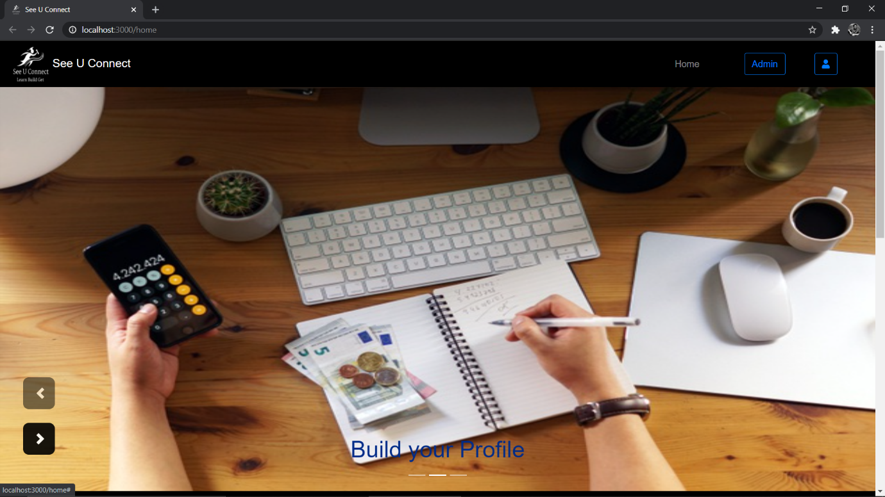

8.1.1 Carousel of Home Page

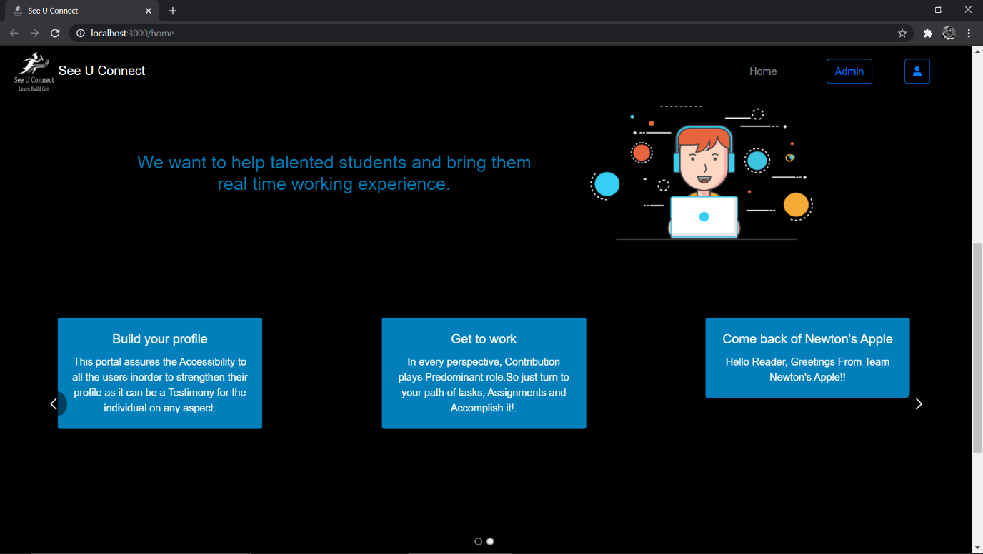

8.1.2 About See U Connect & Latest News

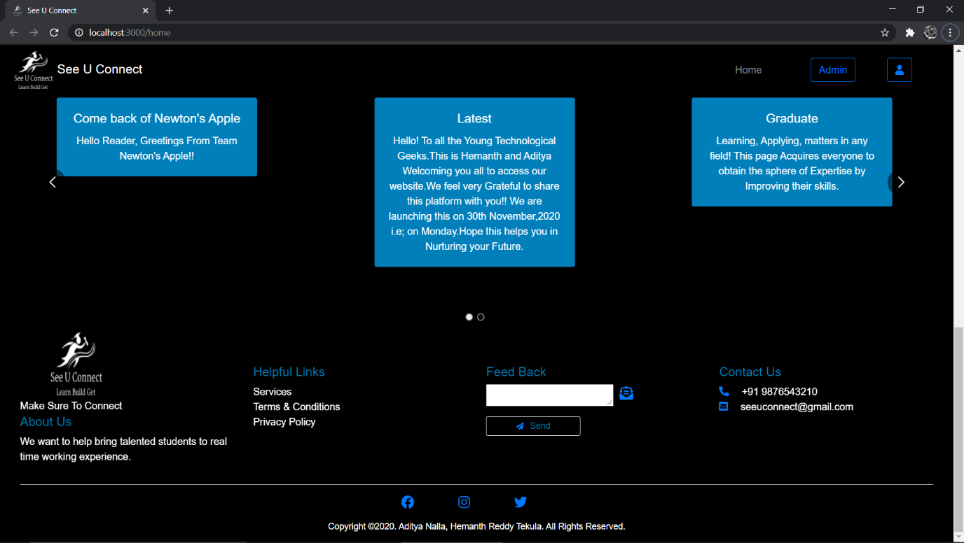

8.1.3. Footer of See U Connect

**8.2 Admin Module**

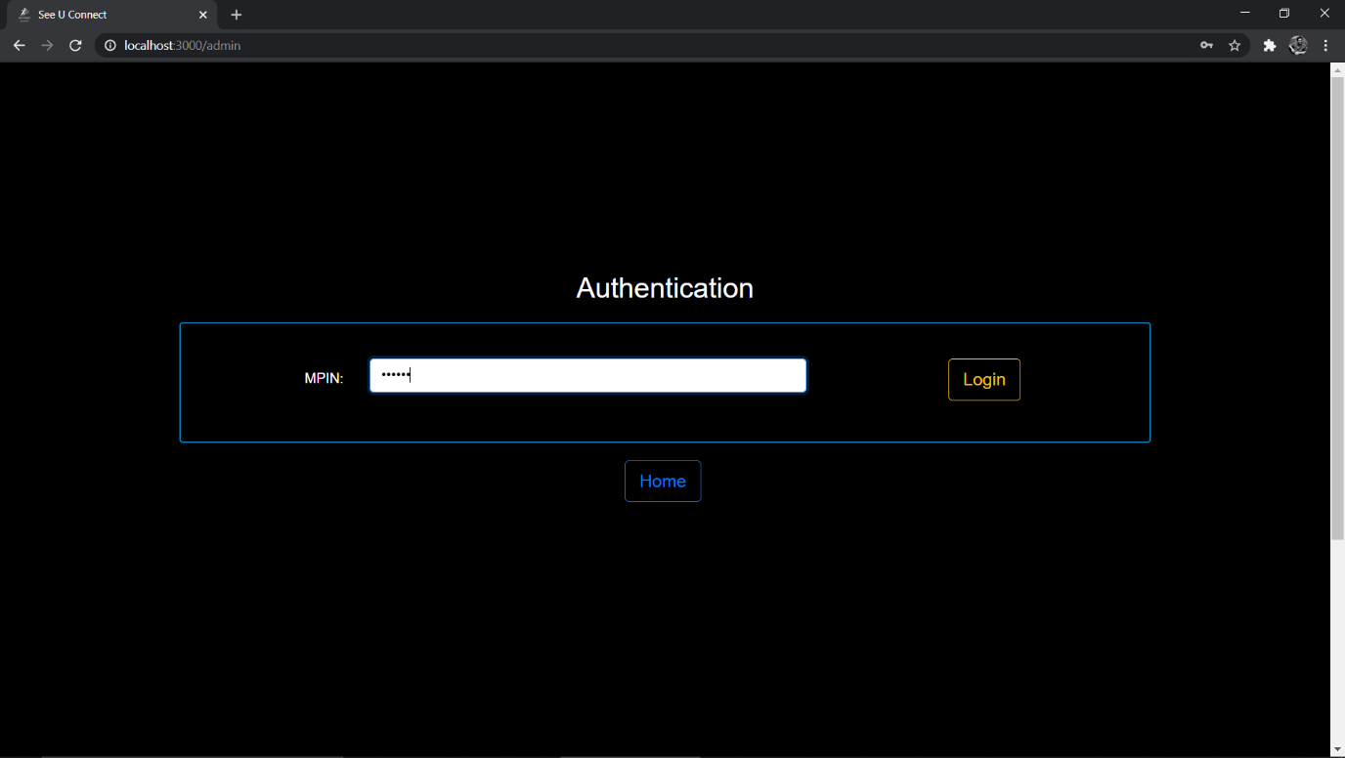

8.2.1 Admin Authentication

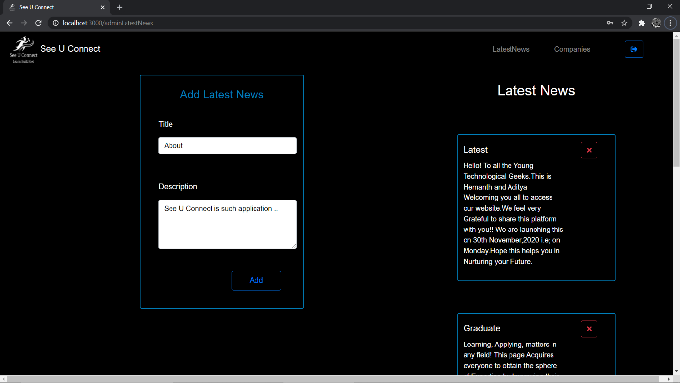

8.2.2 Latest news added by Admin

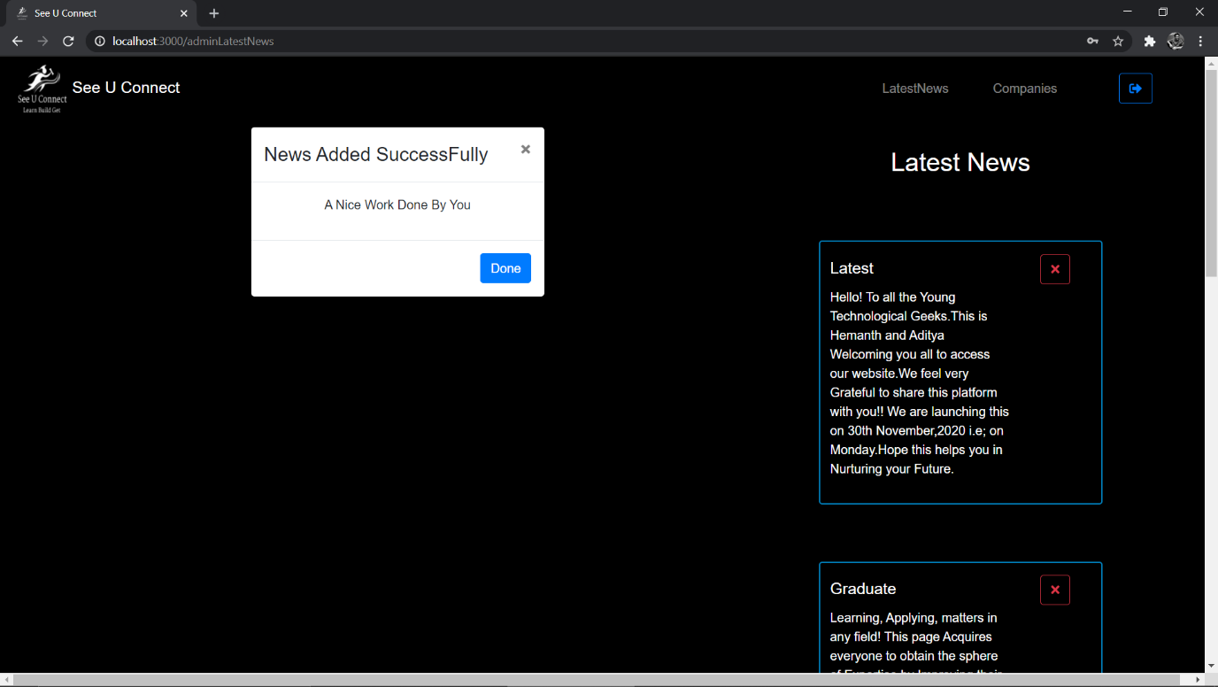

8.2.3 Latest news added successfully

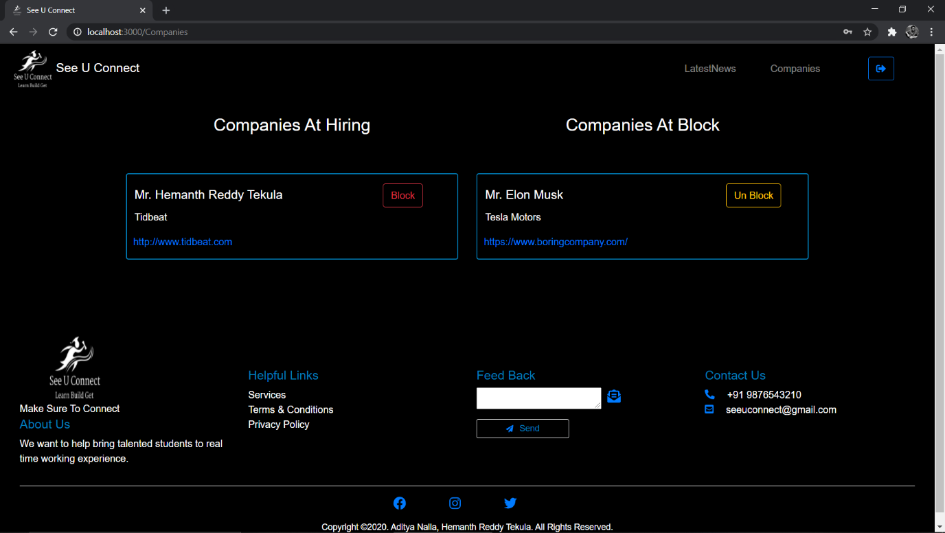

8.2.4 Companies at hire and at block controlled by Admin

**8.3 Alumni Module**

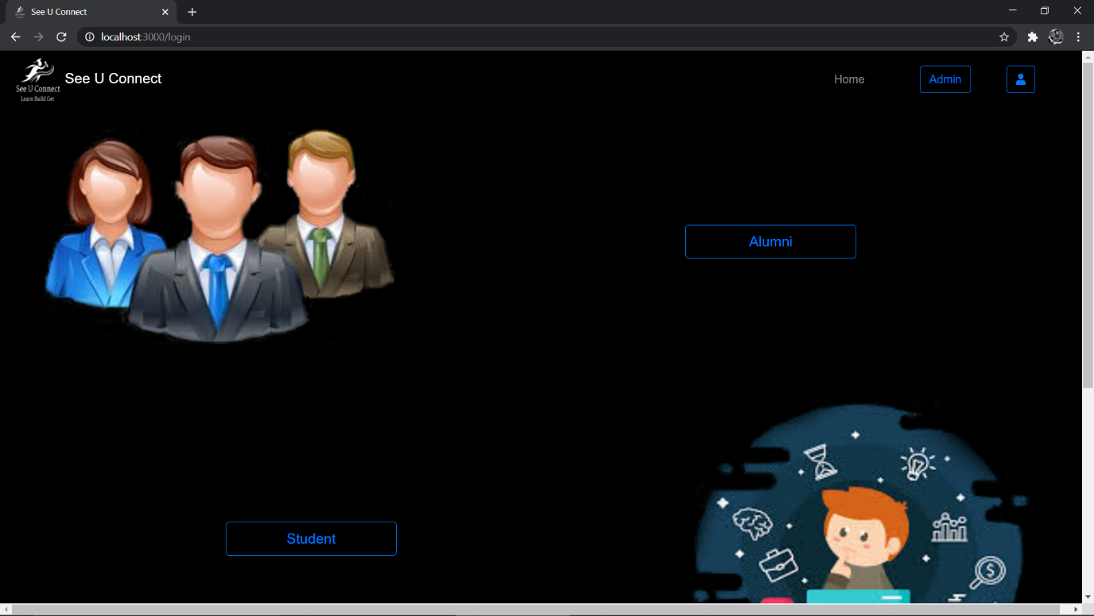

8.3.1 Partition for Alumni and Student

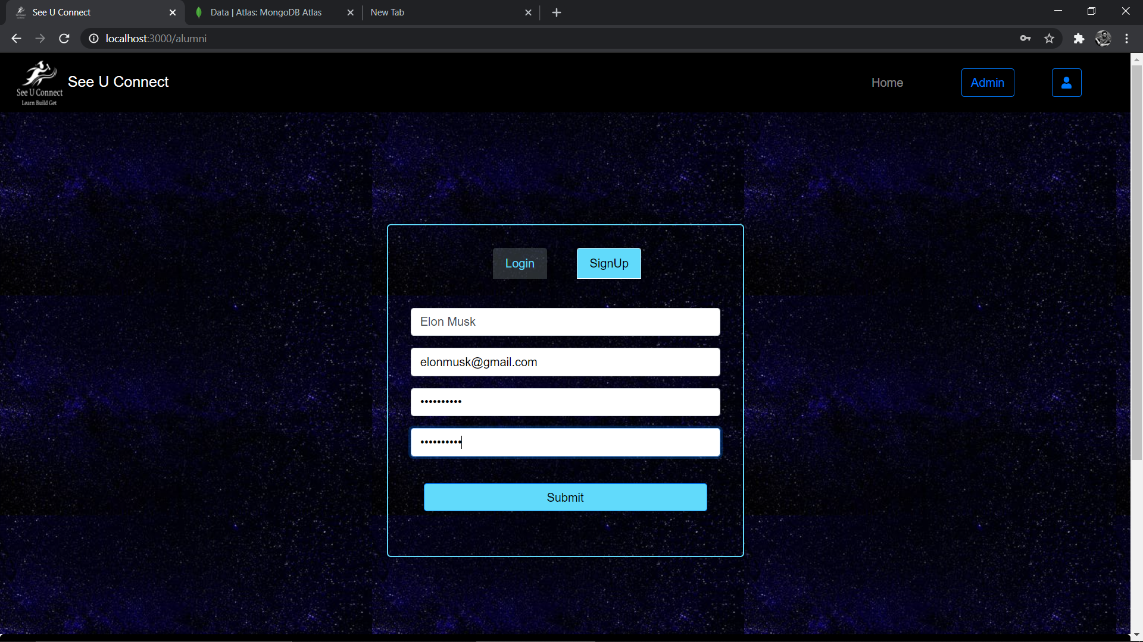

8.3.2 Sign Up page for Alumni

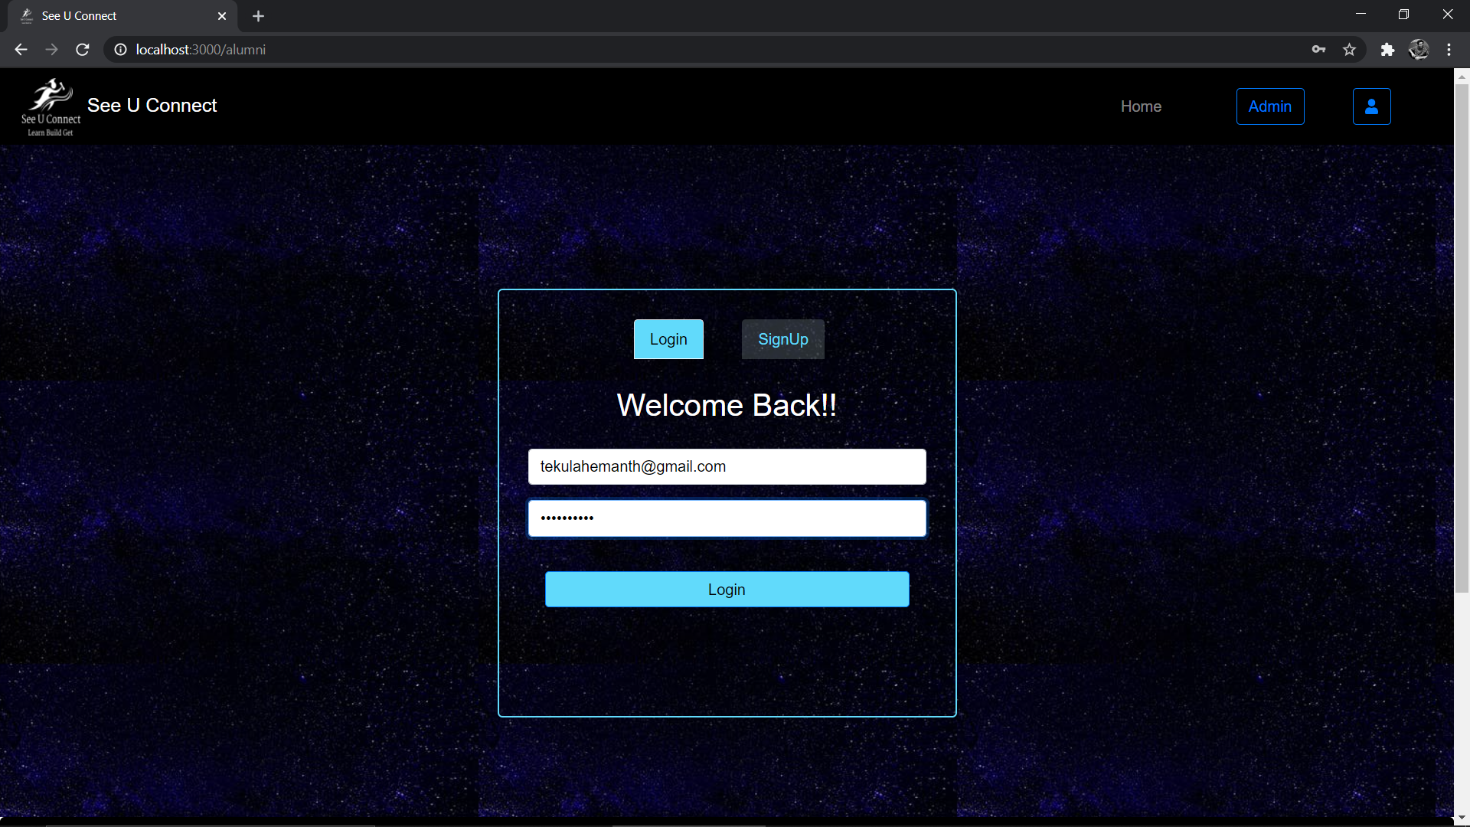

8.3.3 Log in page for Alumni

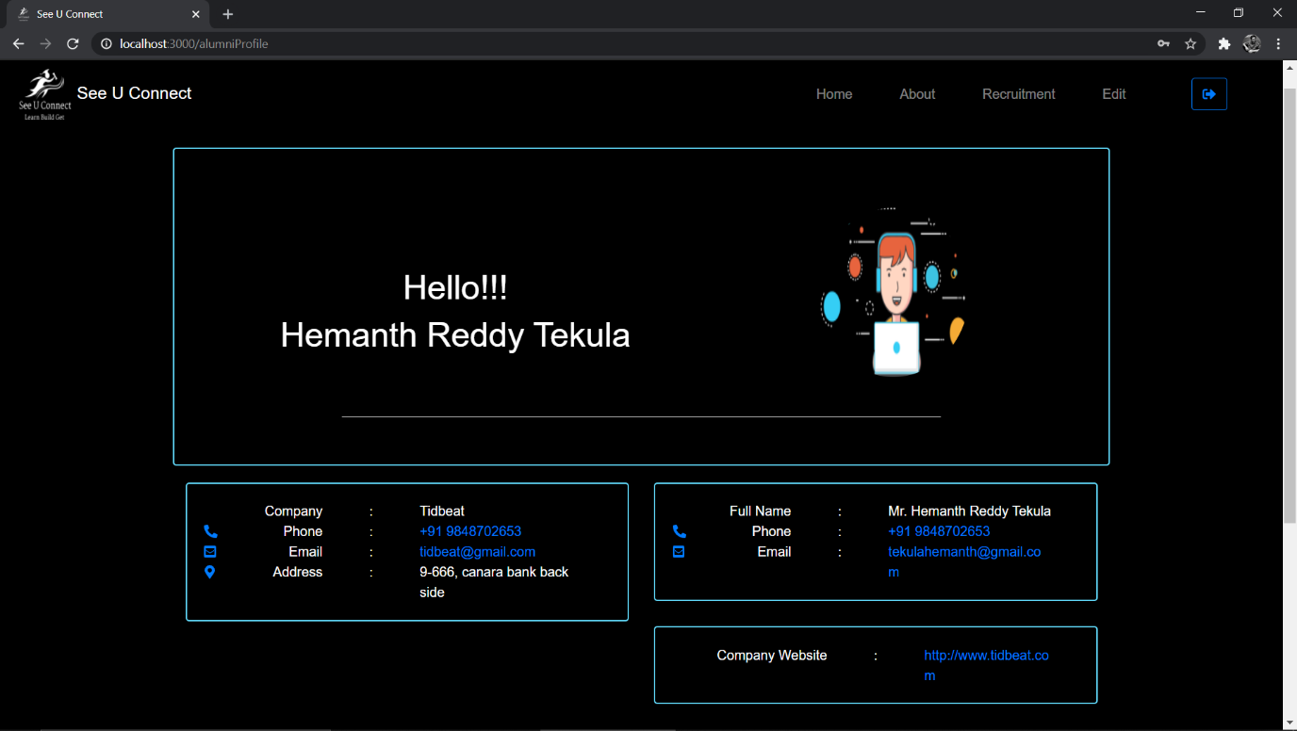

8.3.4 Profile page for Alumni

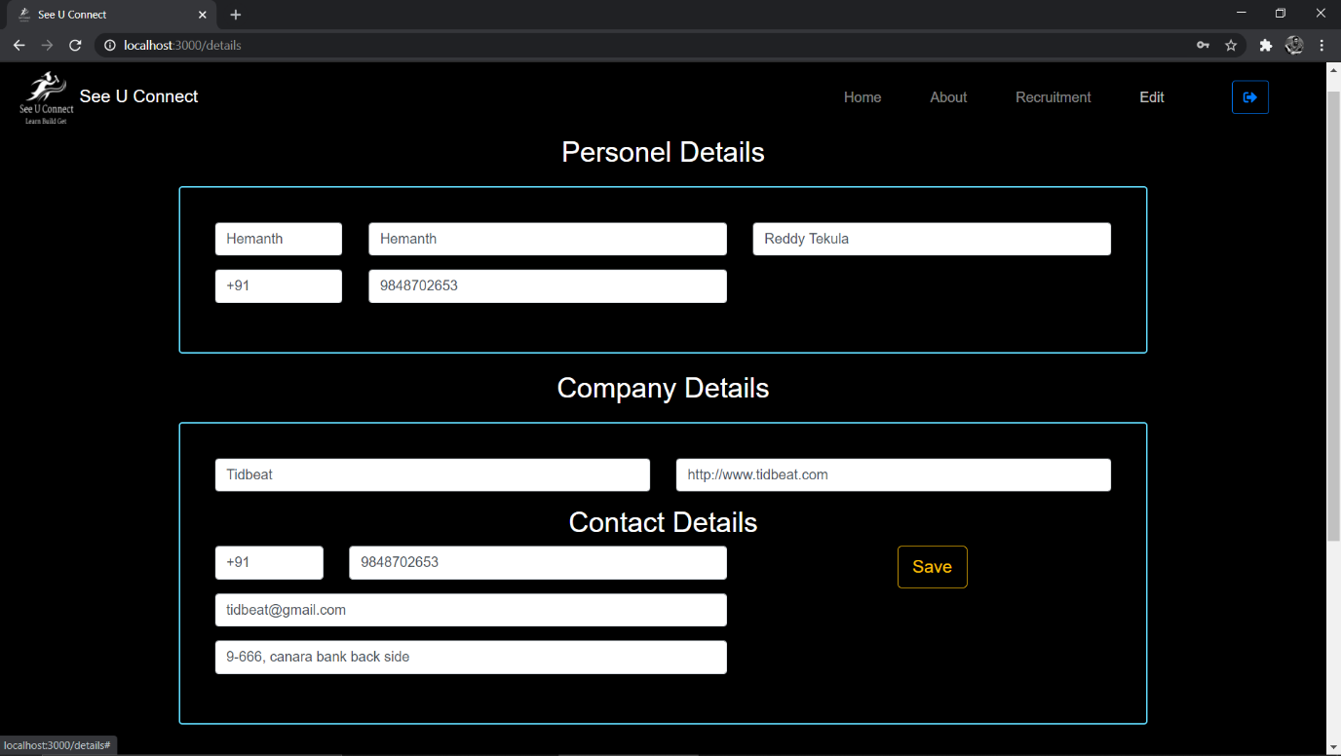

8.3.5 Edit Alumni Details page

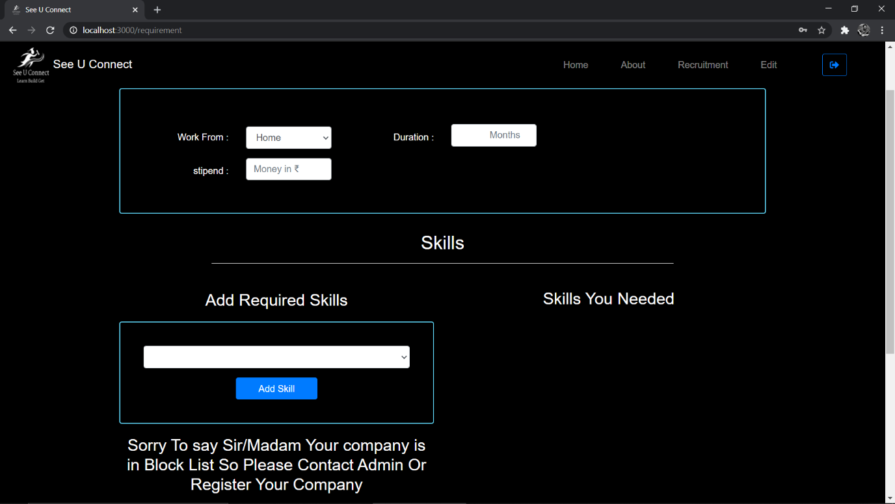

8.3.6 If Company is in Block List

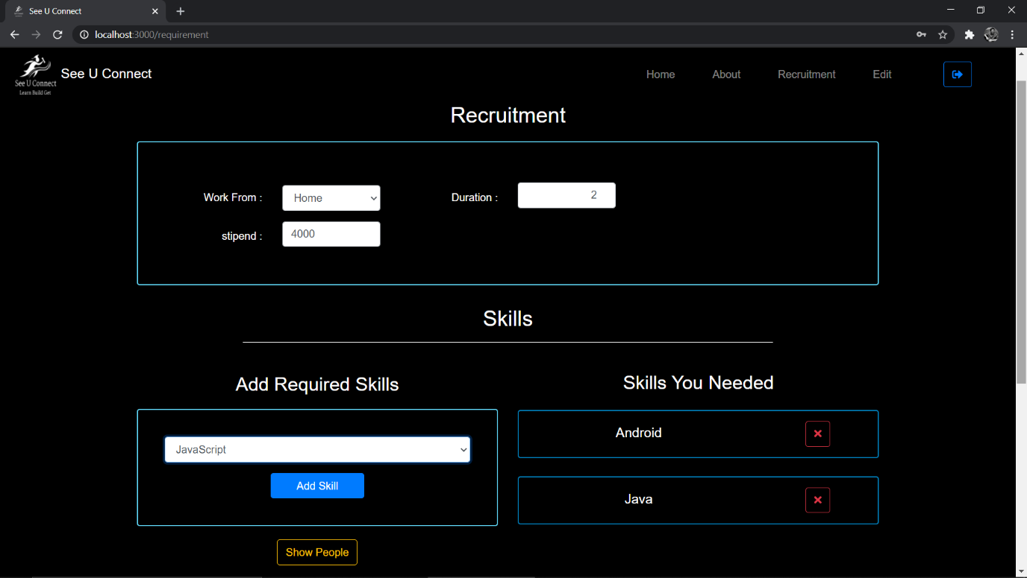

8.3.7 If Company is at Hiring

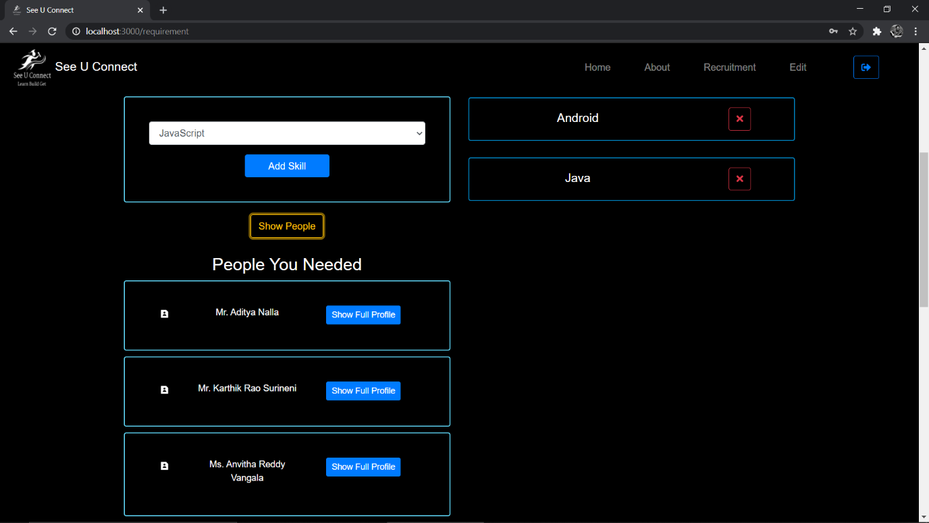

8.3.8 List of people according to the requirements for Alumni

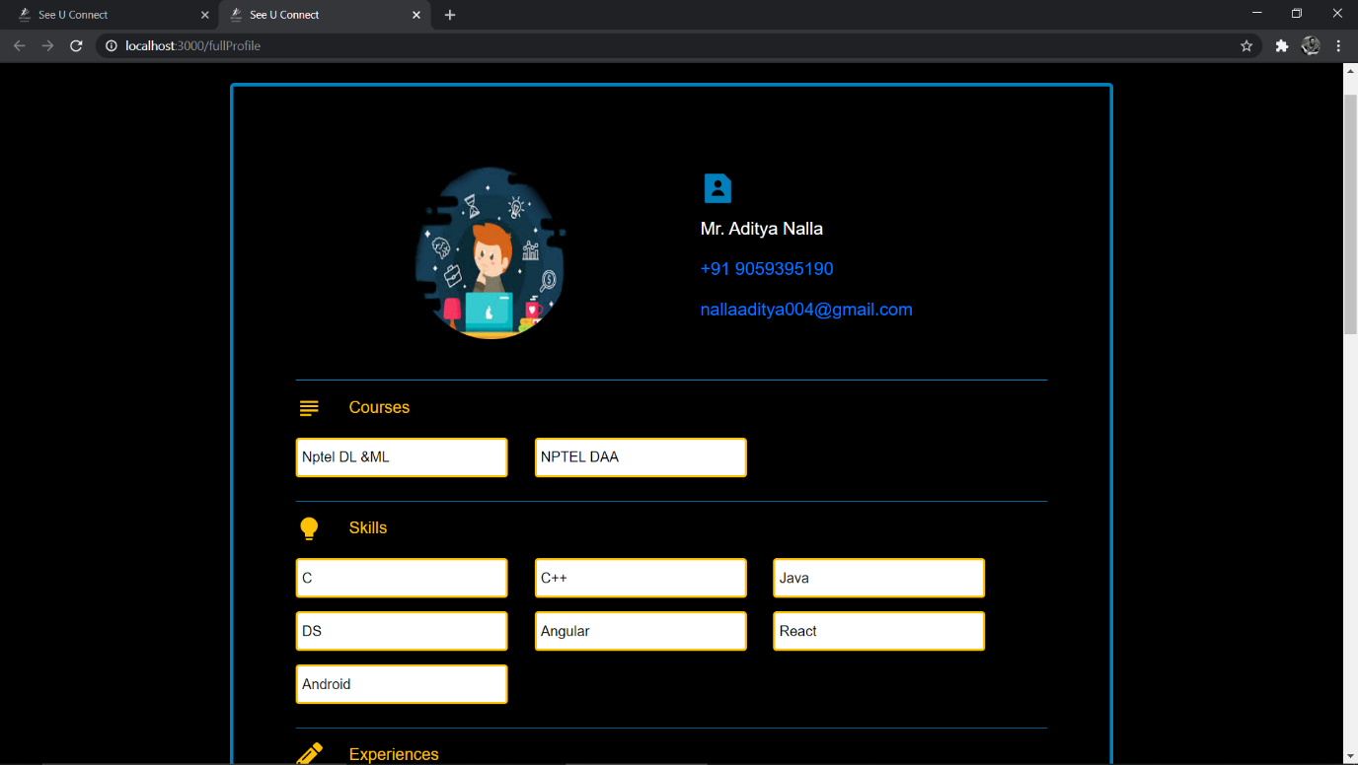

8.3.9 Student Profile Courses and Skills

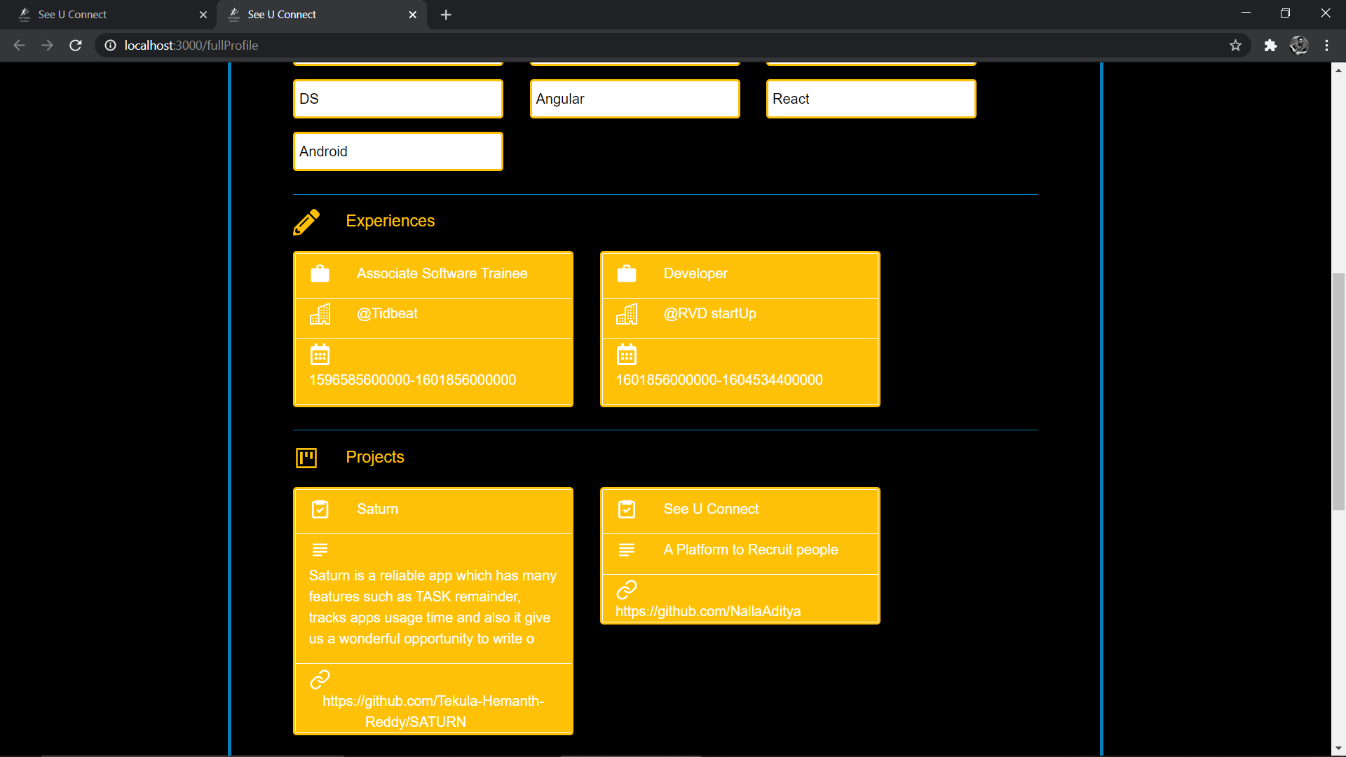

8.3.10 Student Profile Experiences and Projects

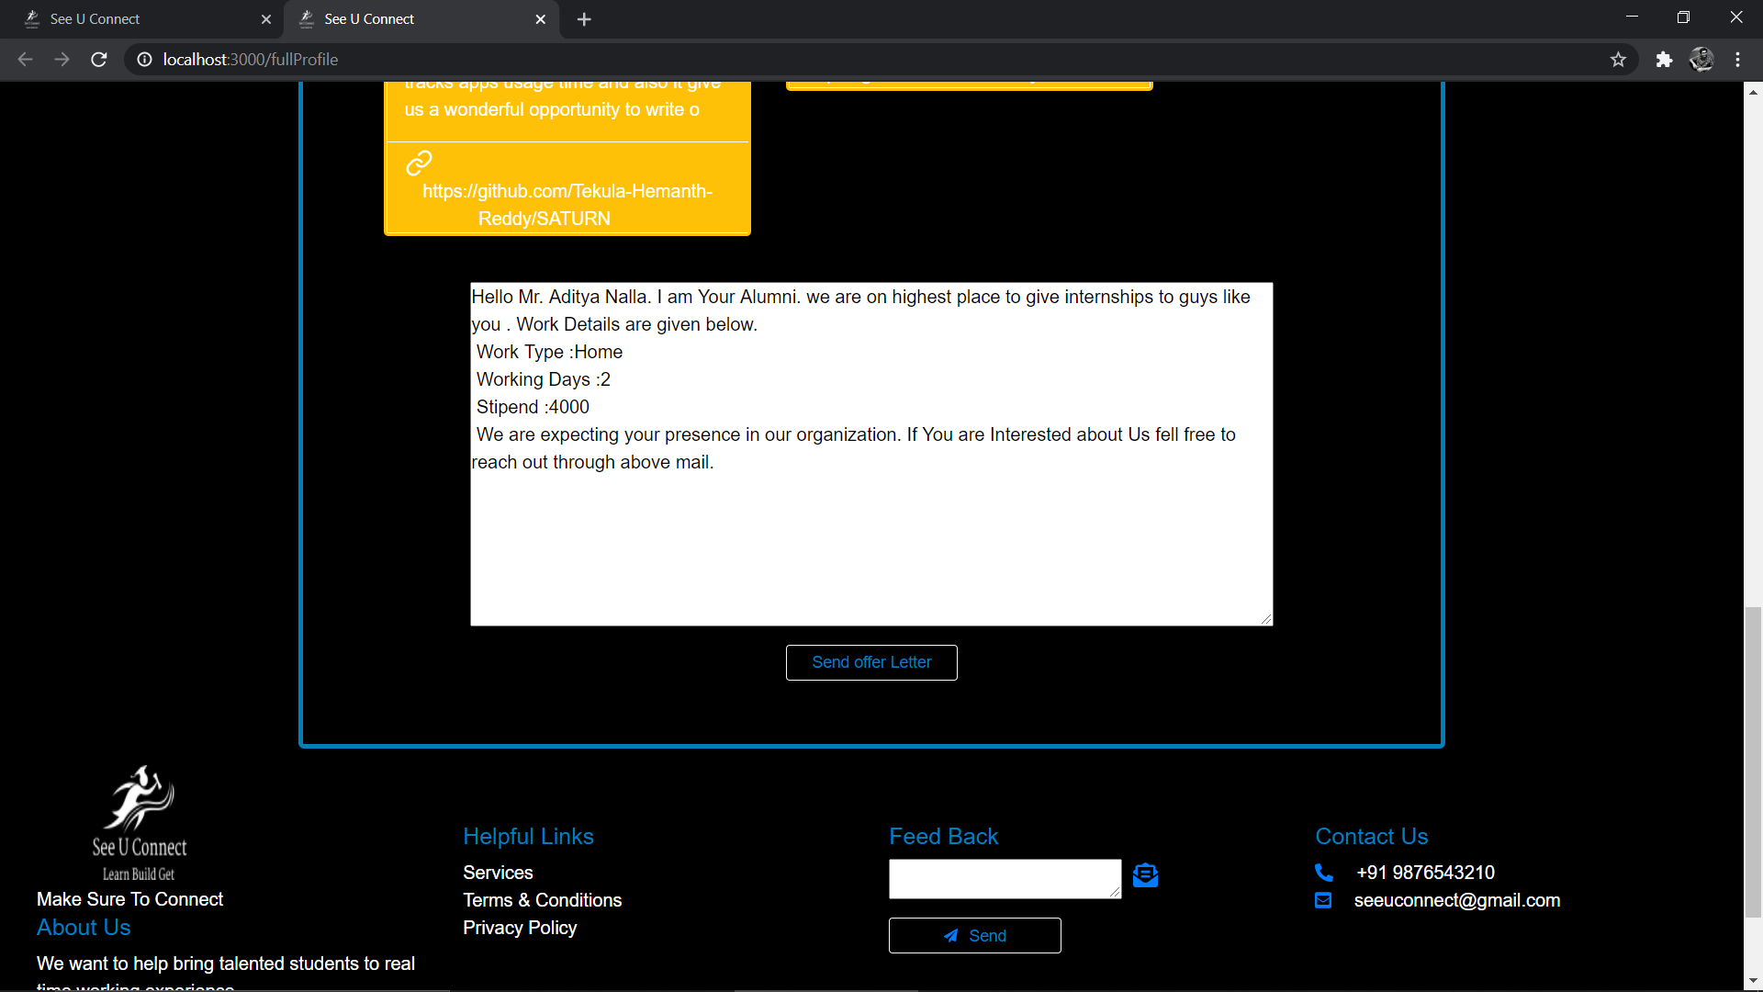

8.3.11 Offer Letter for Student

**8.4 Student Module**

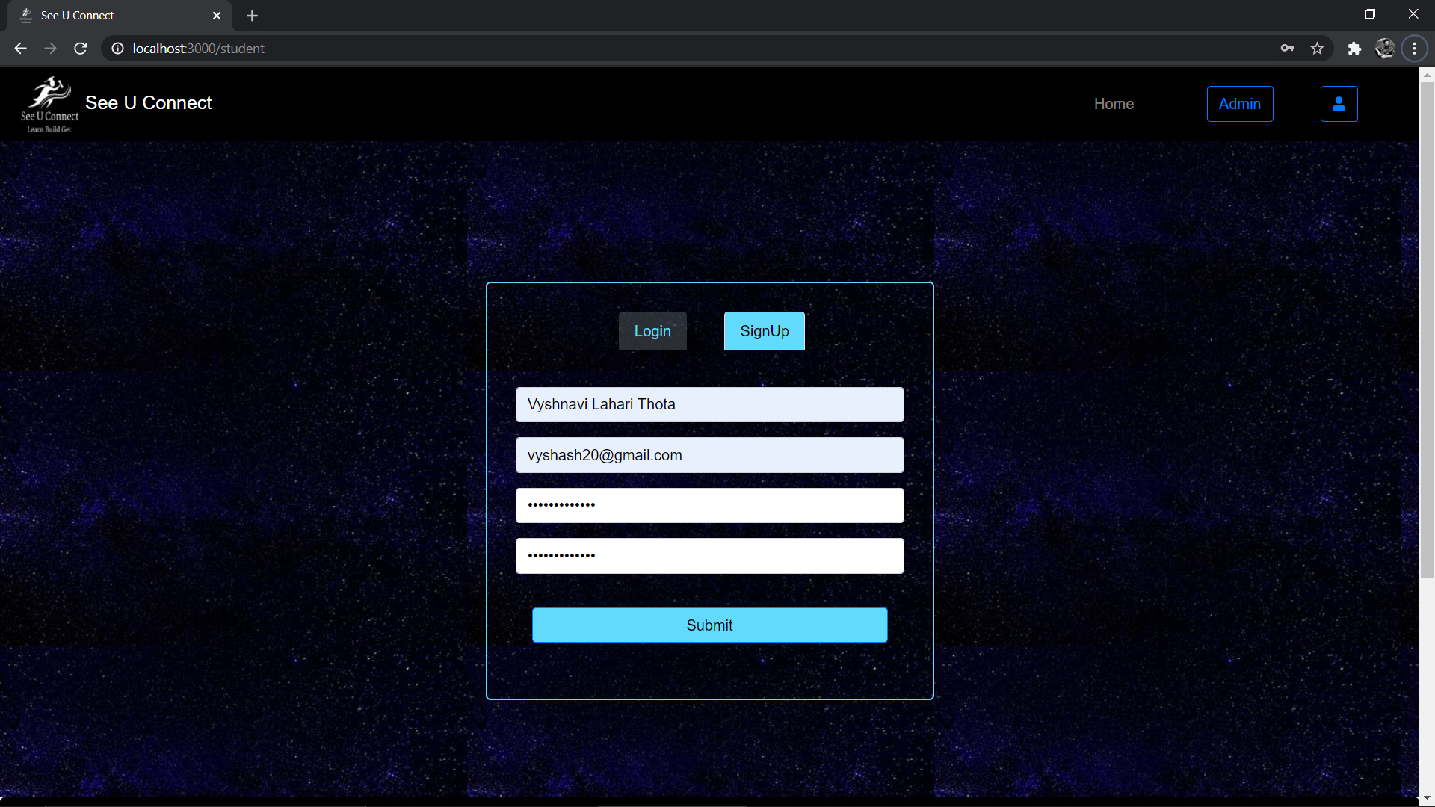

8.4.1 Sign Up for Student

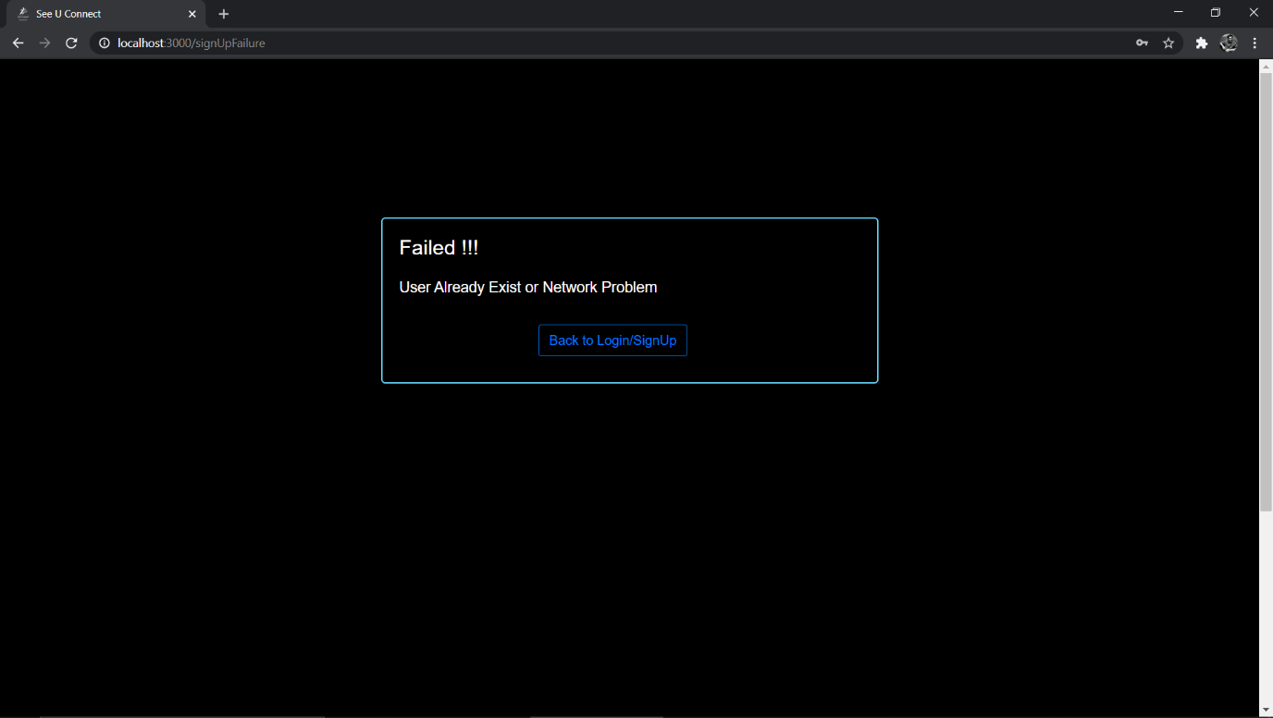

8.4.2 Sign Up Failure

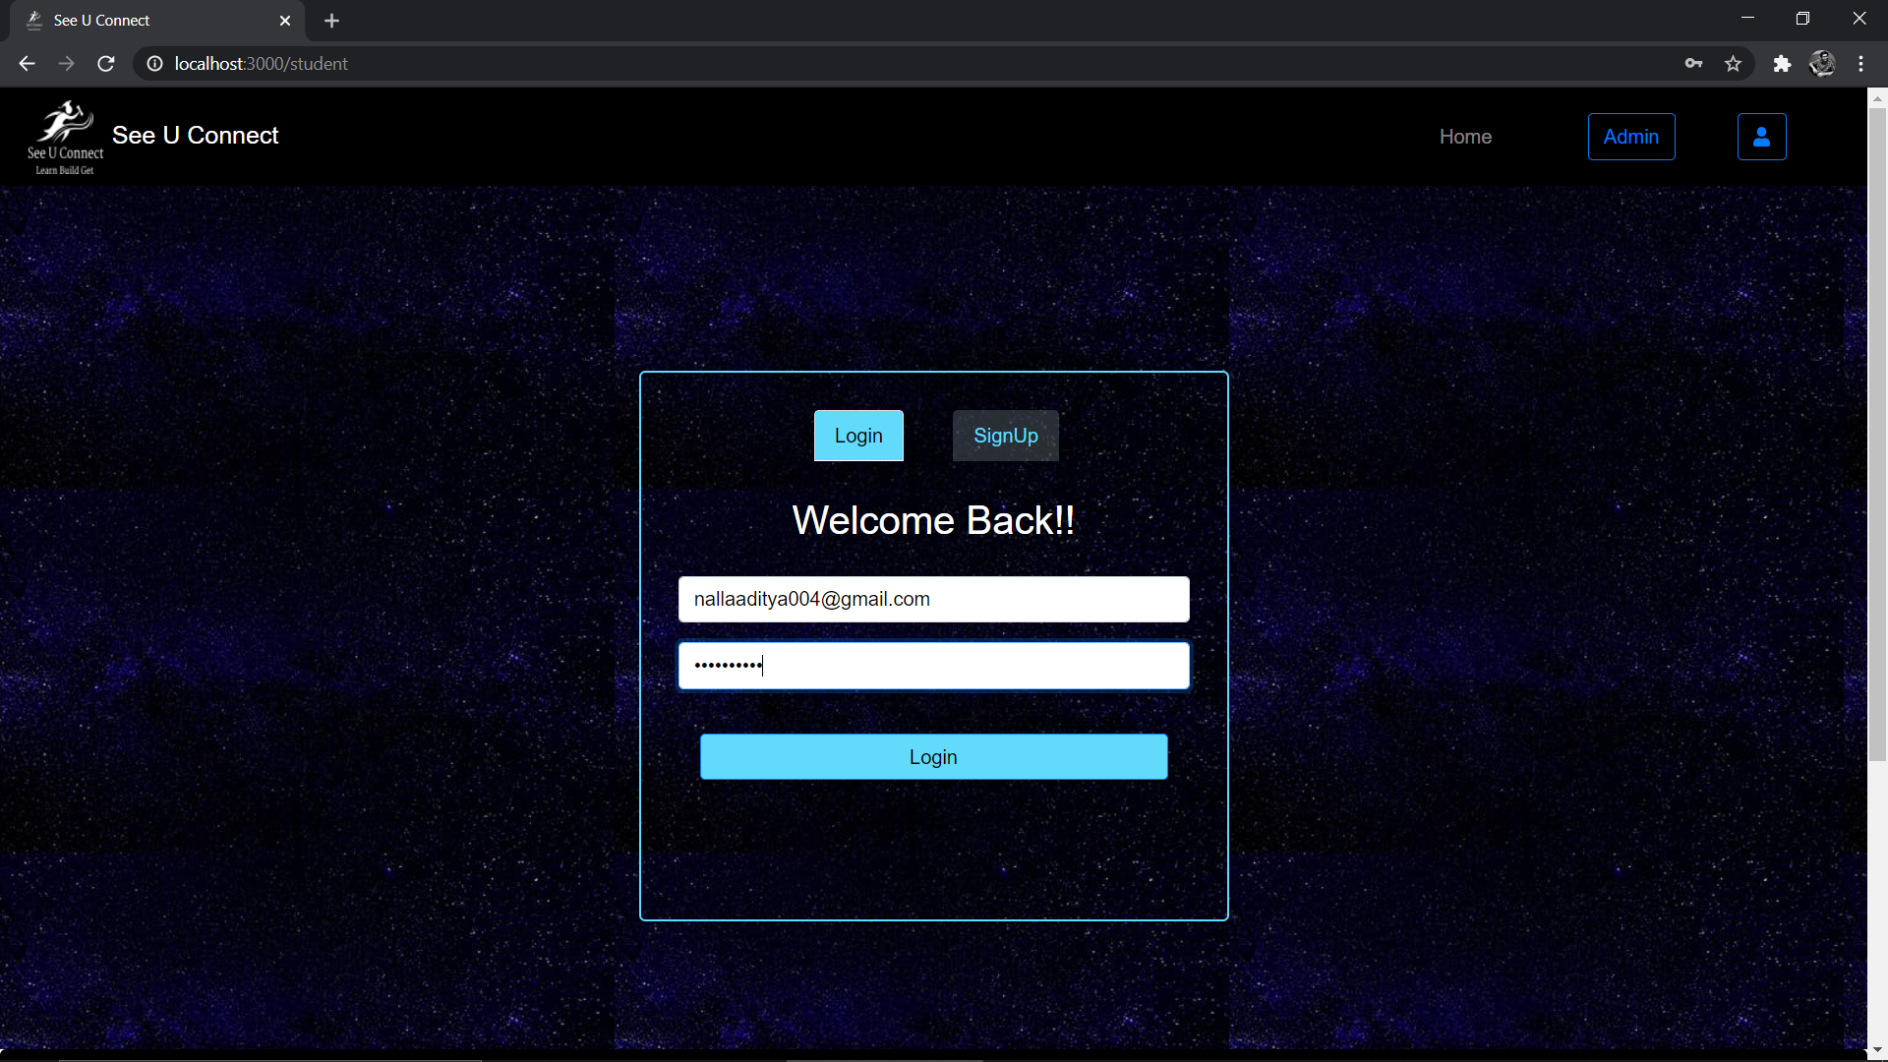

8.4.3 Login page for Student

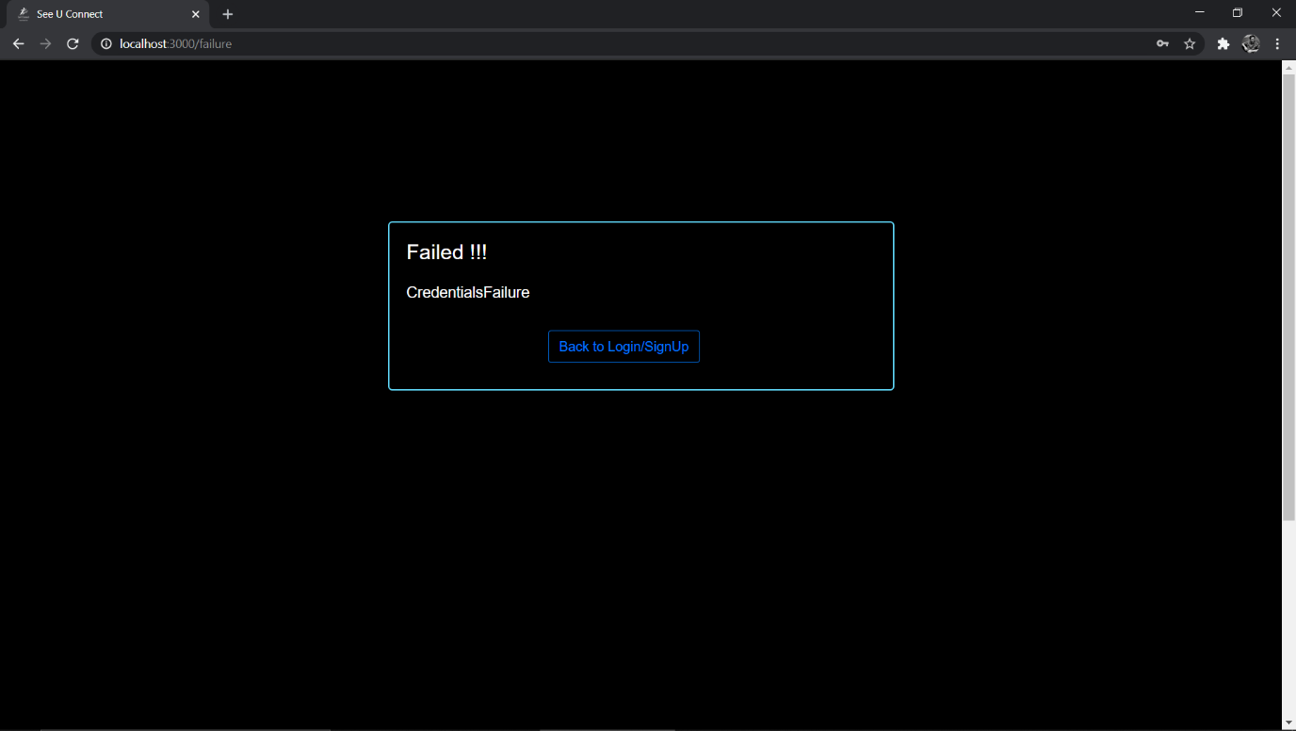

8.4.4 Login Failure

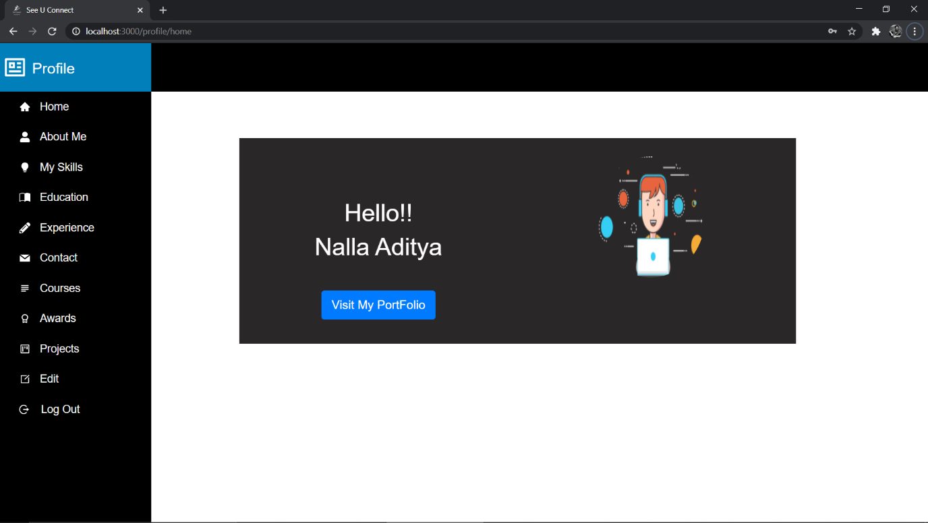

8.4.5 Profile of Student

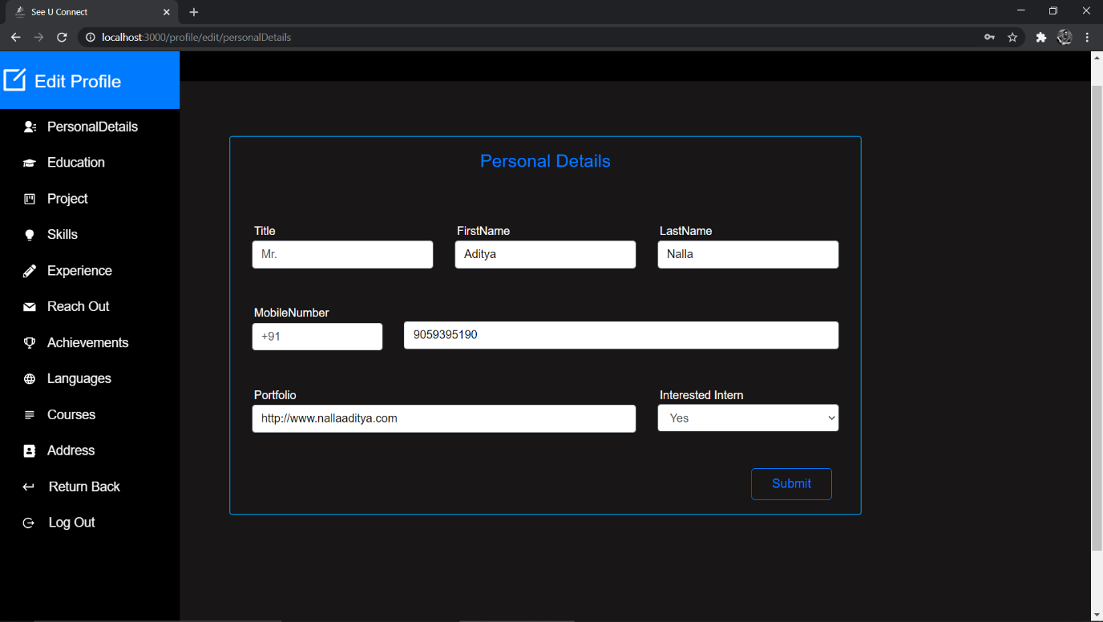

8.4.6 Personal Details edit page for student

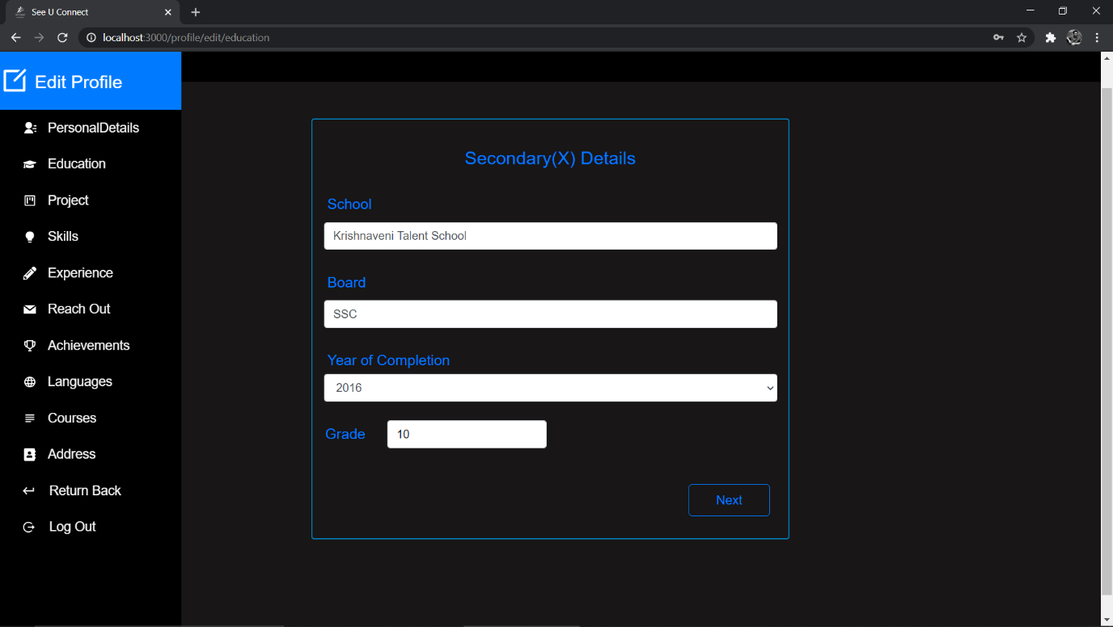

8.4.7 Secondary Education

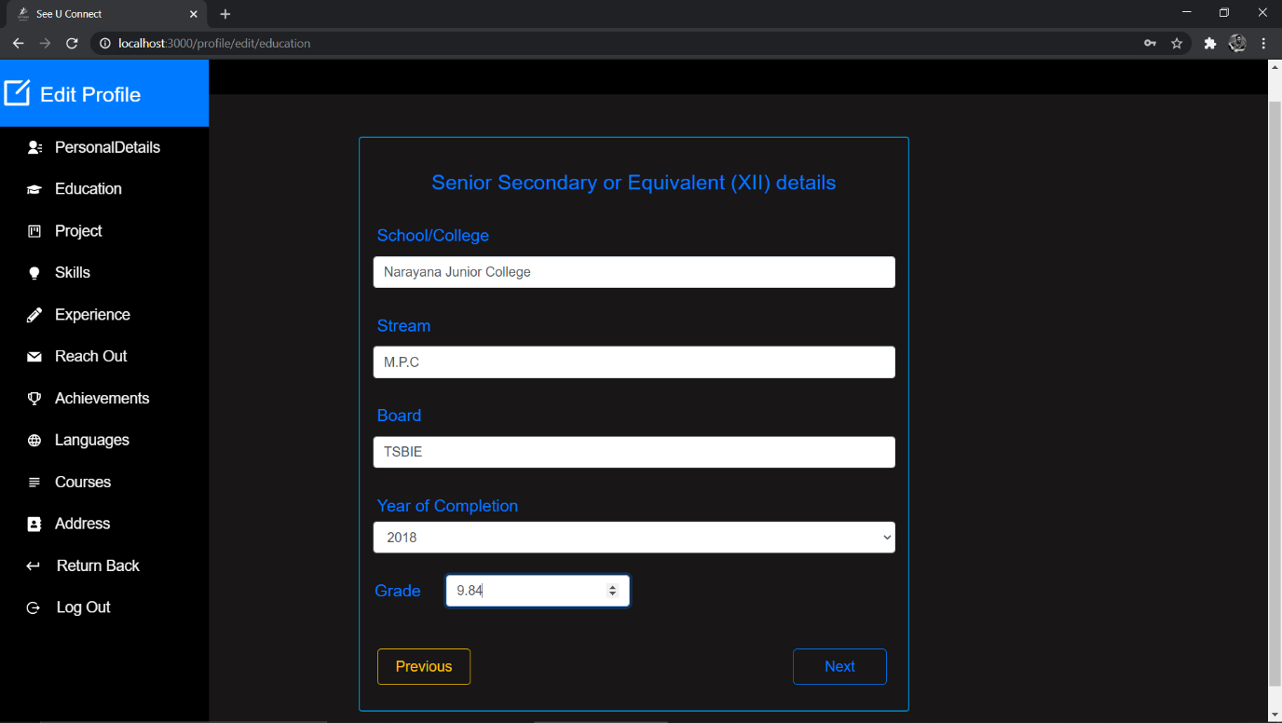

8.4.8 Senior Secondary Education

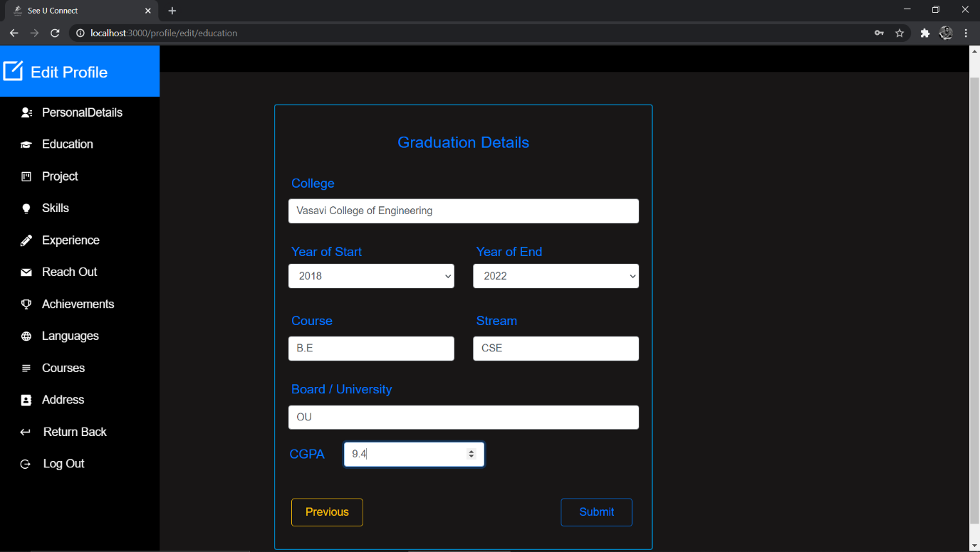

8.4.9 Graduation Details

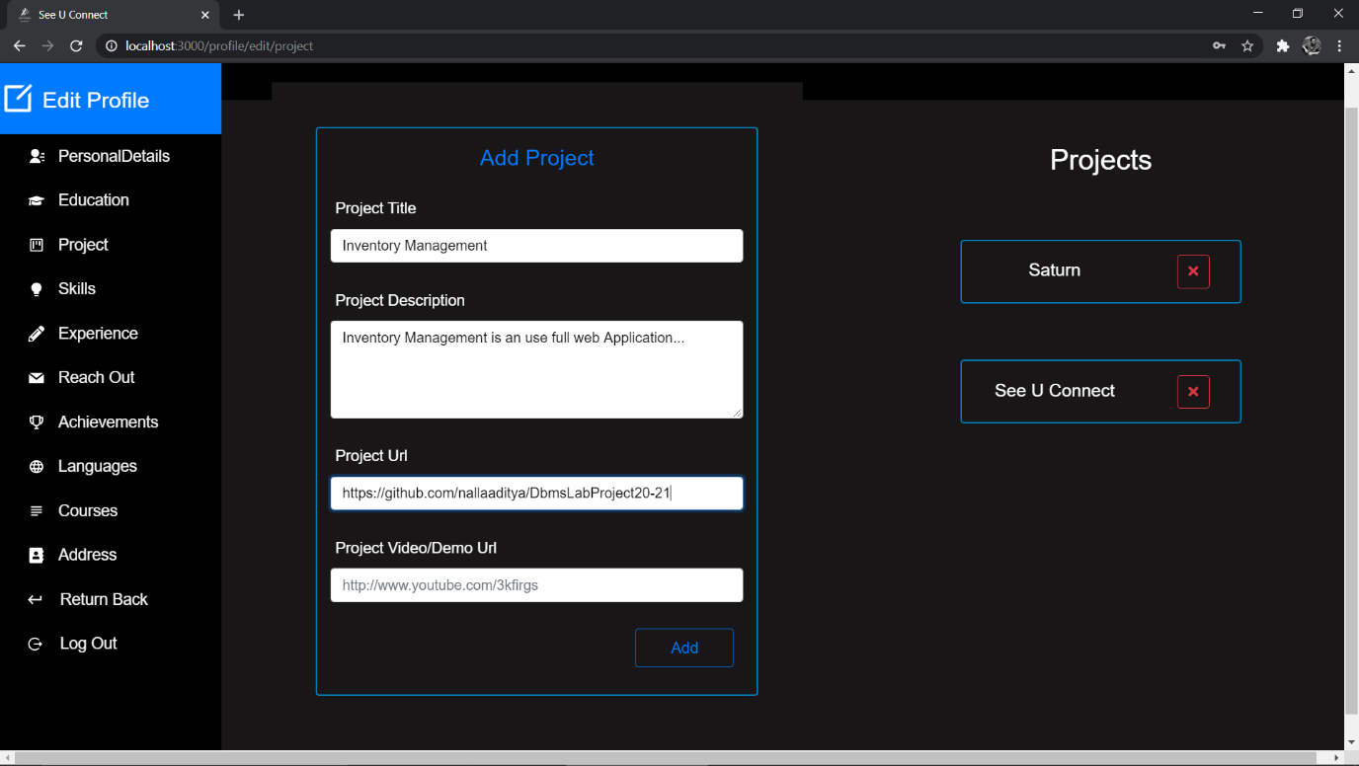

8.4.10 Add Projects

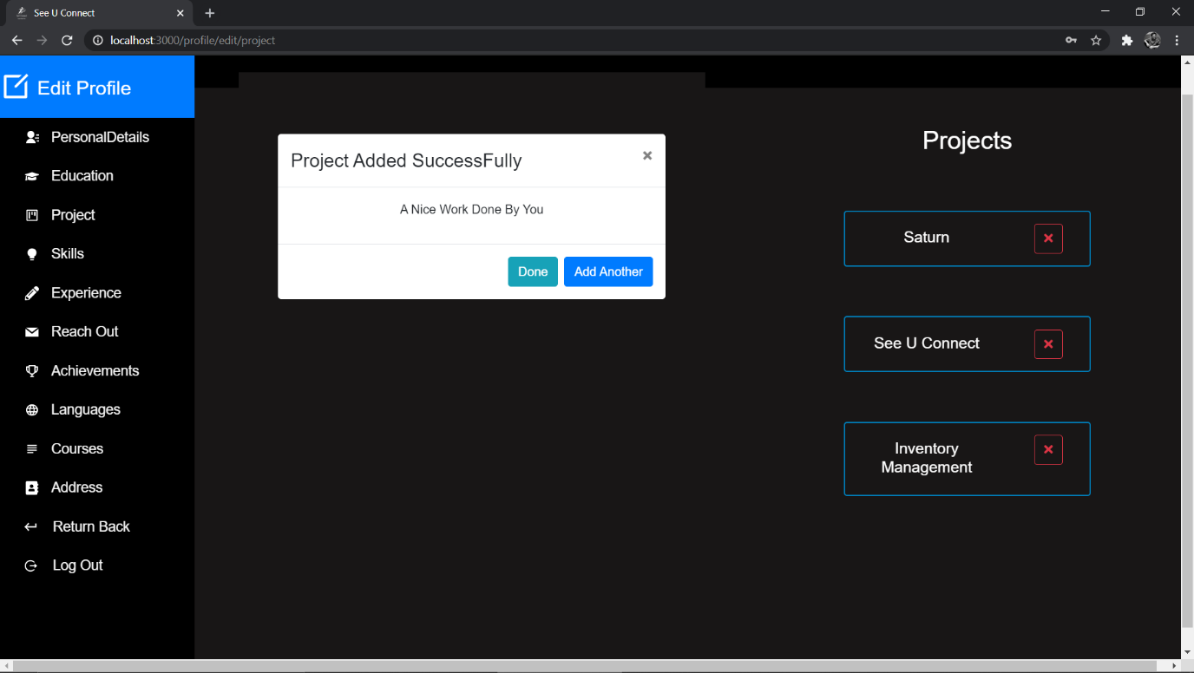

8.4.11 Project added Successfully

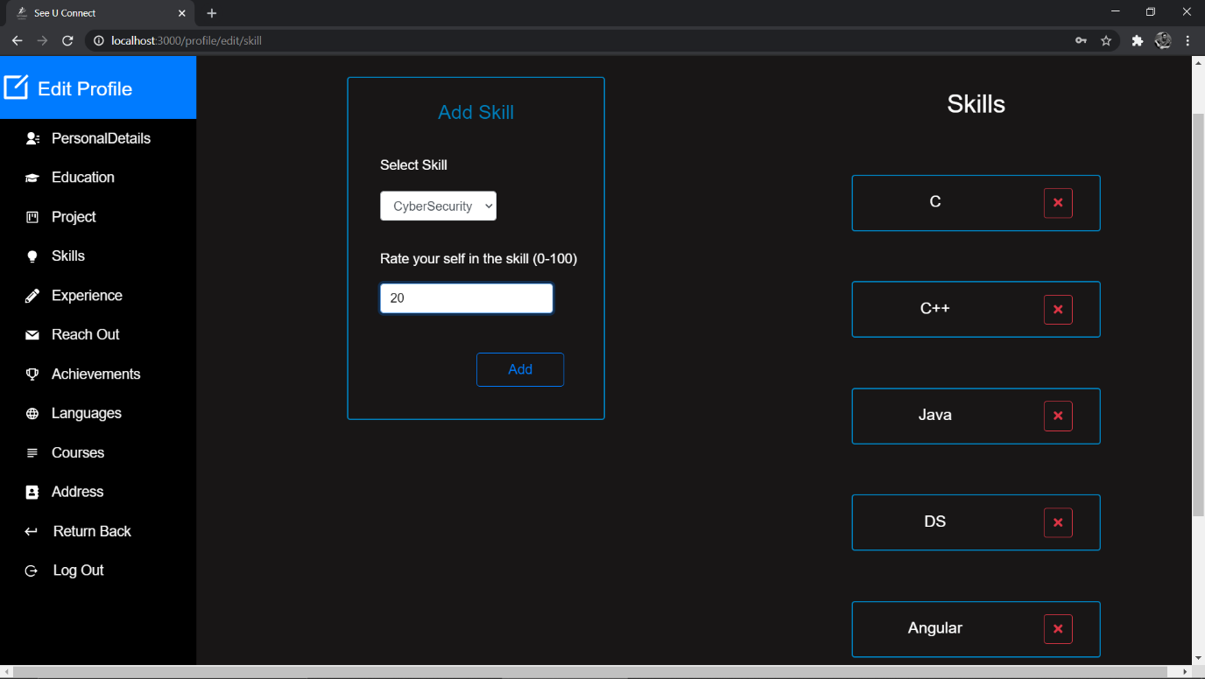

8.4.12 Add Skill

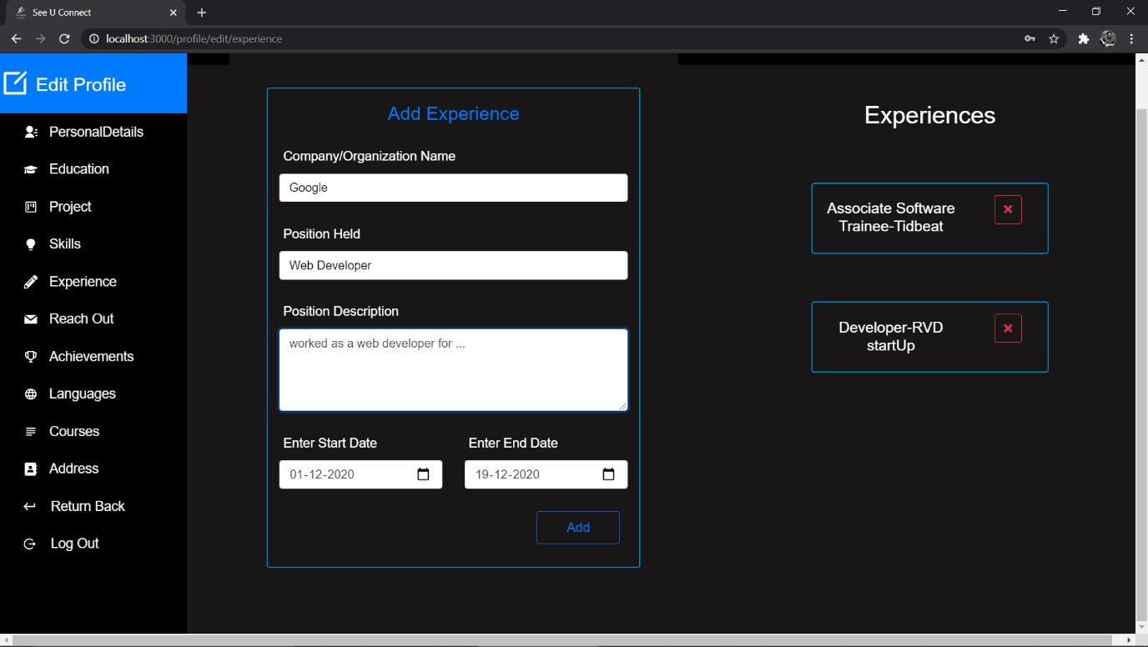

8.4.13 Add Experience

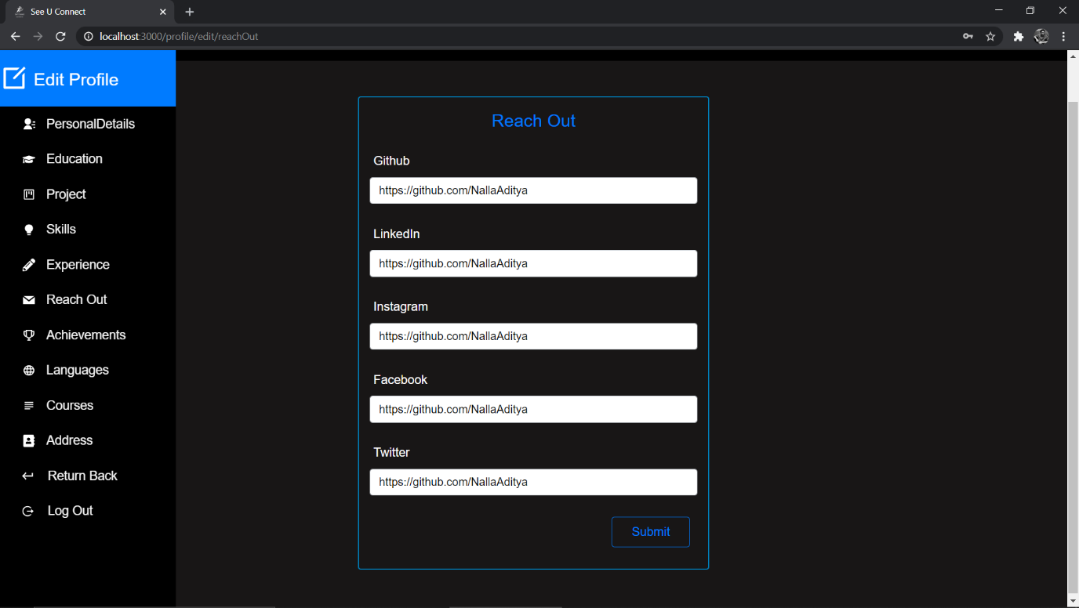

8.4.14 Add Reachouts

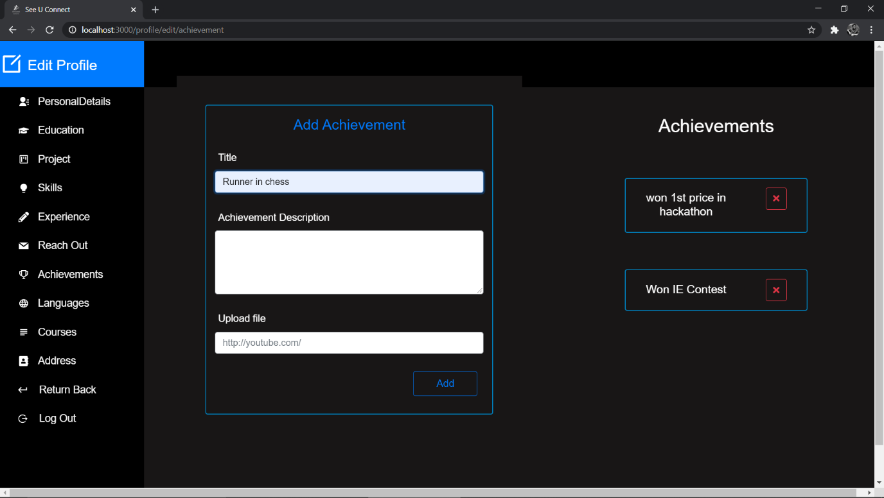

8.4.15 Add Achievements

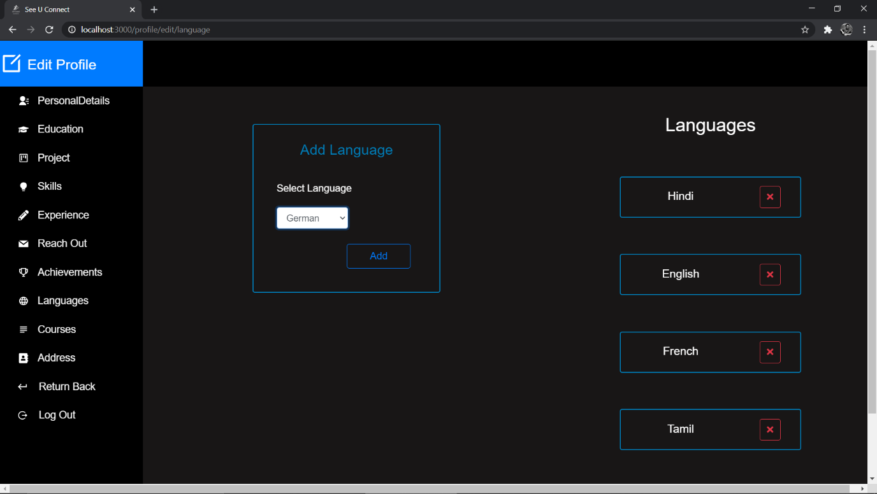

8.4.16 Add languages Known to students

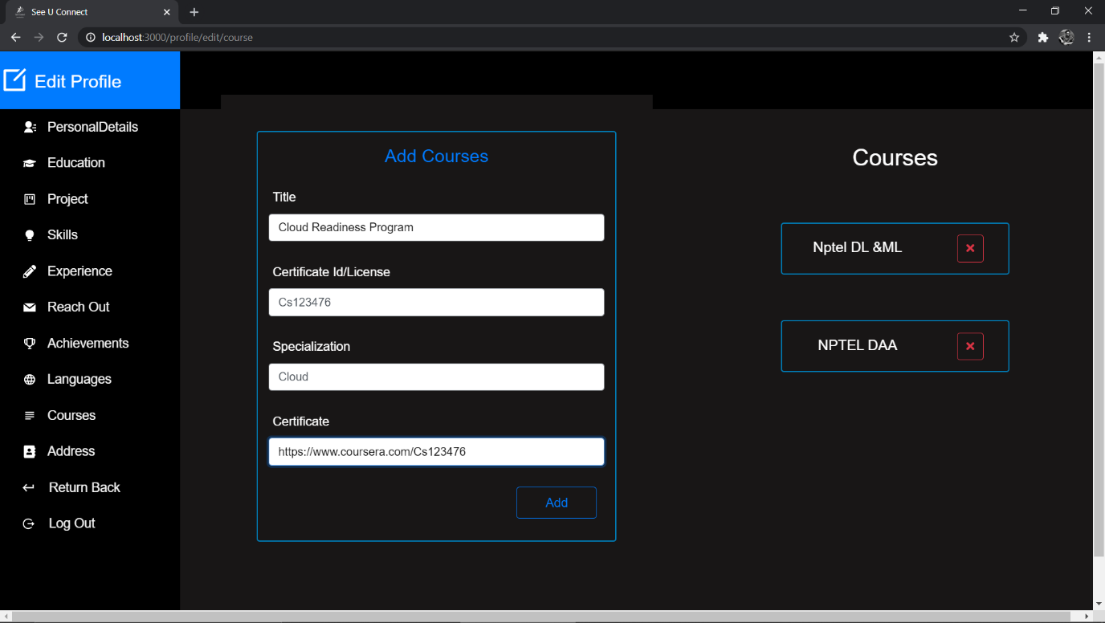

8.4.17 Add Courses done by Student

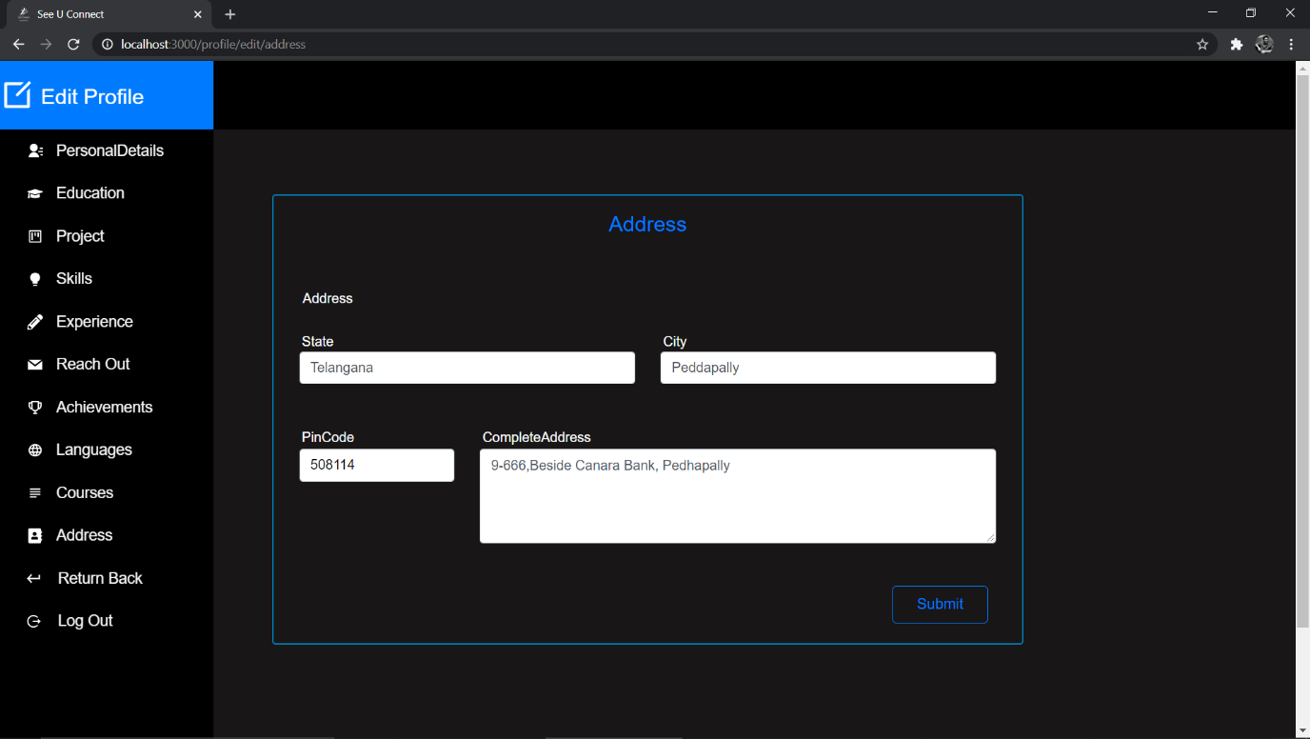

8.4.18 Address of Student

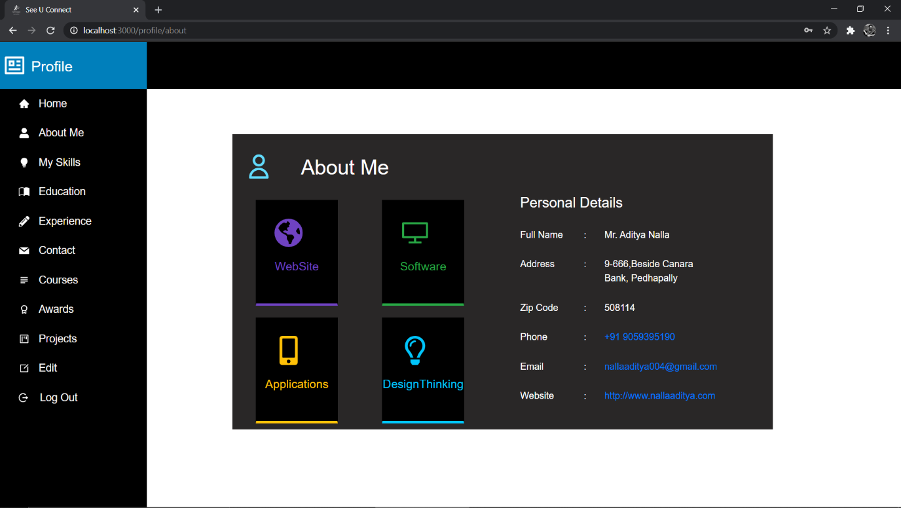

8.4.19 Personal Details of Student

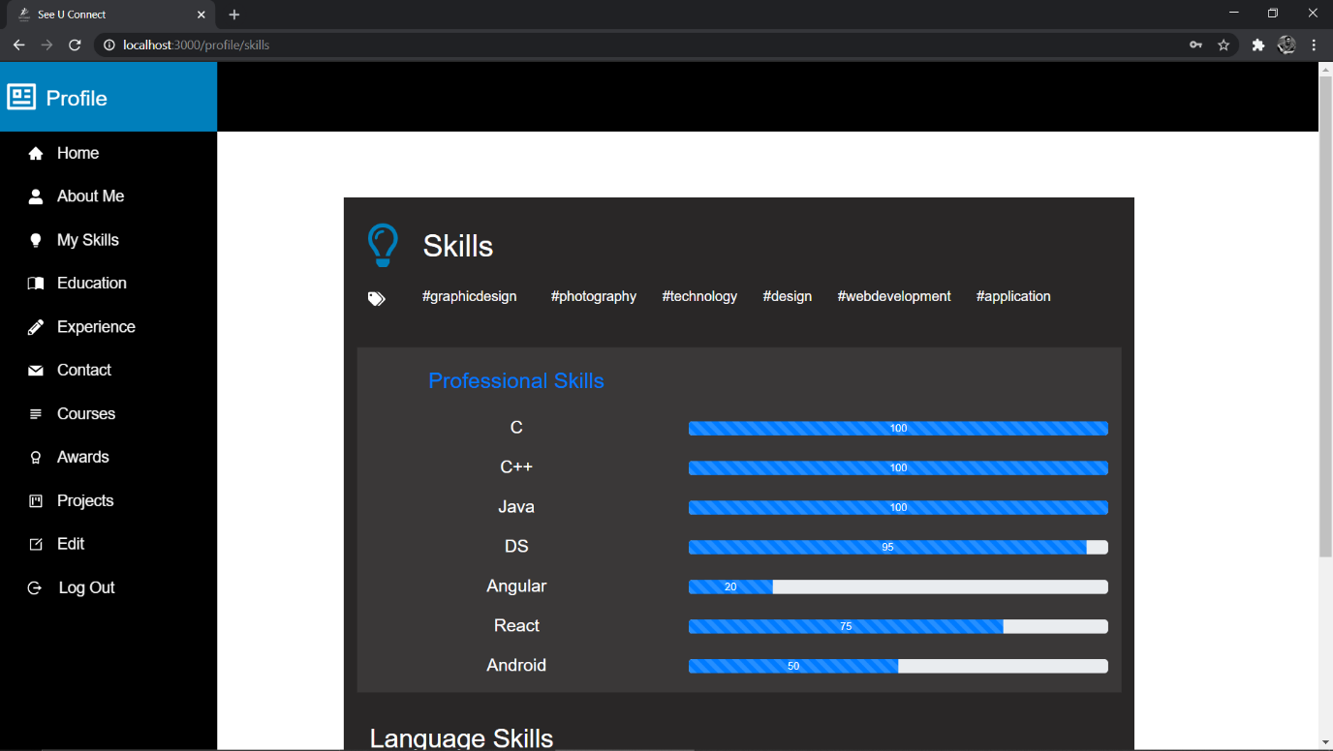

8.4.20 Skills of Student

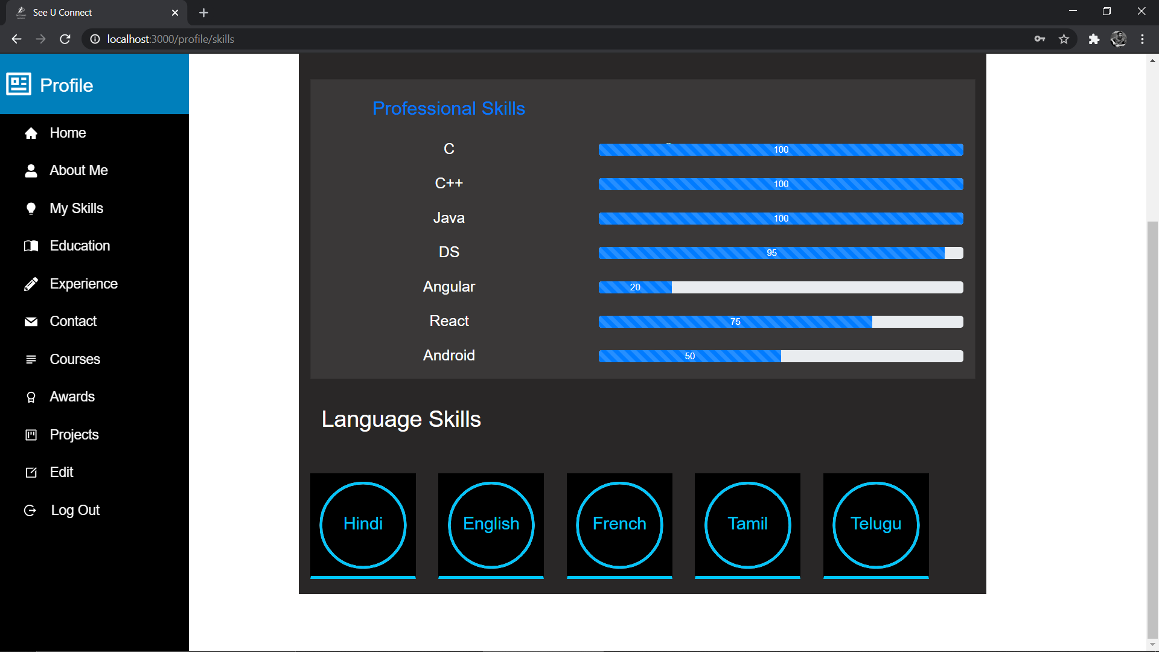

8.4.21 Languages known for student

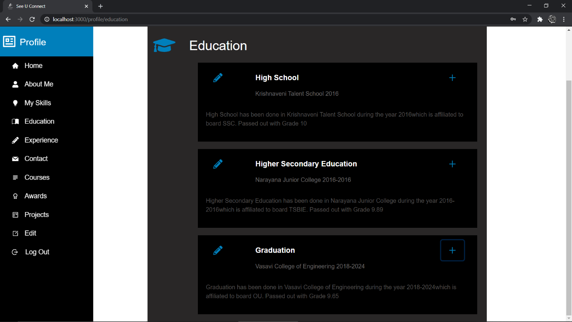

8.4.22 Education Details of Student

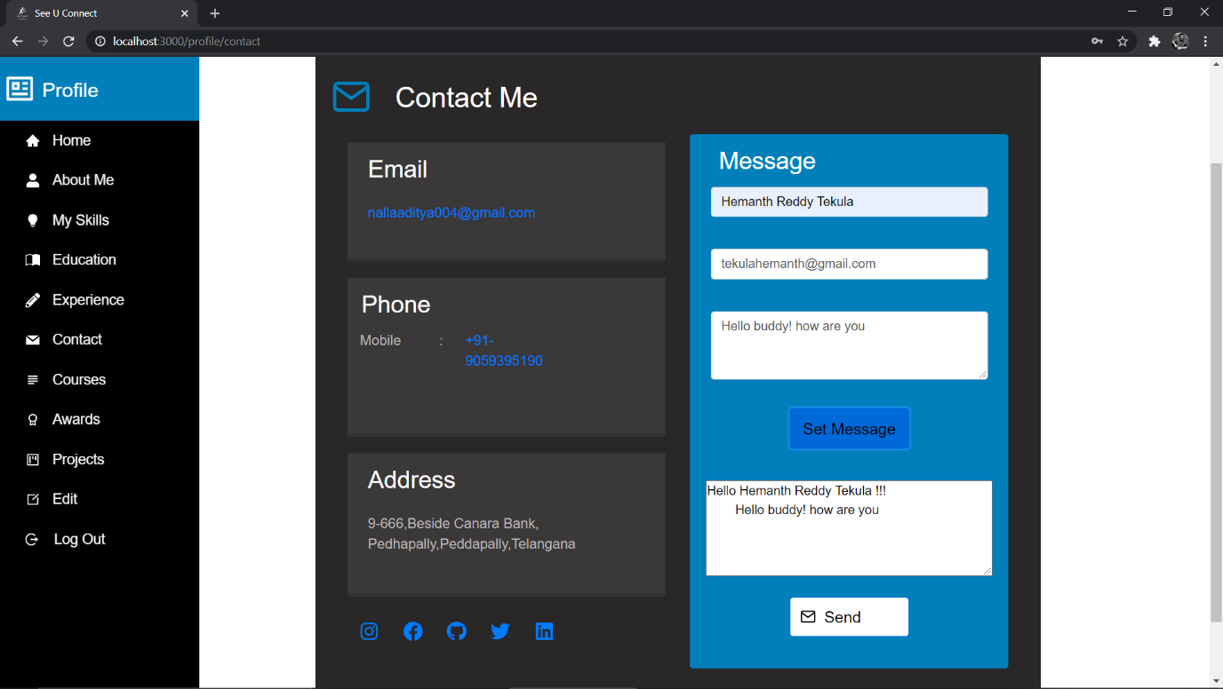

8.4.23 Contact Details of Student

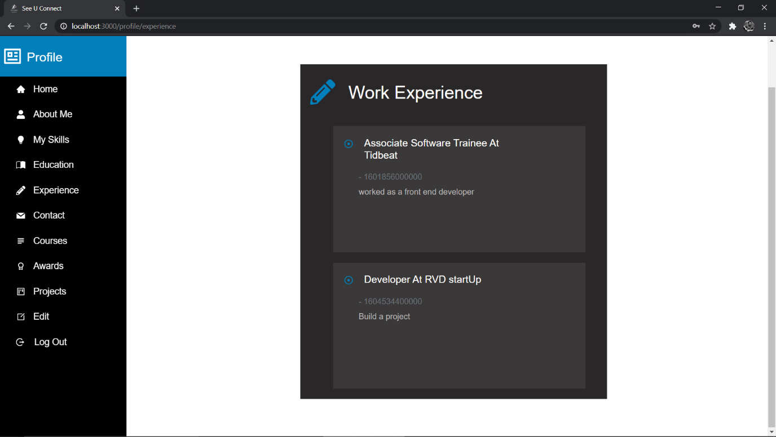

8.4.24 Work Experience of Student

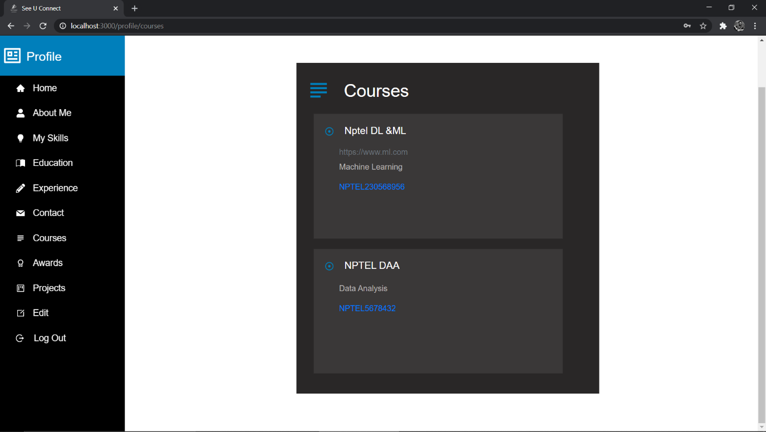

8.4.25 Courses done by Student

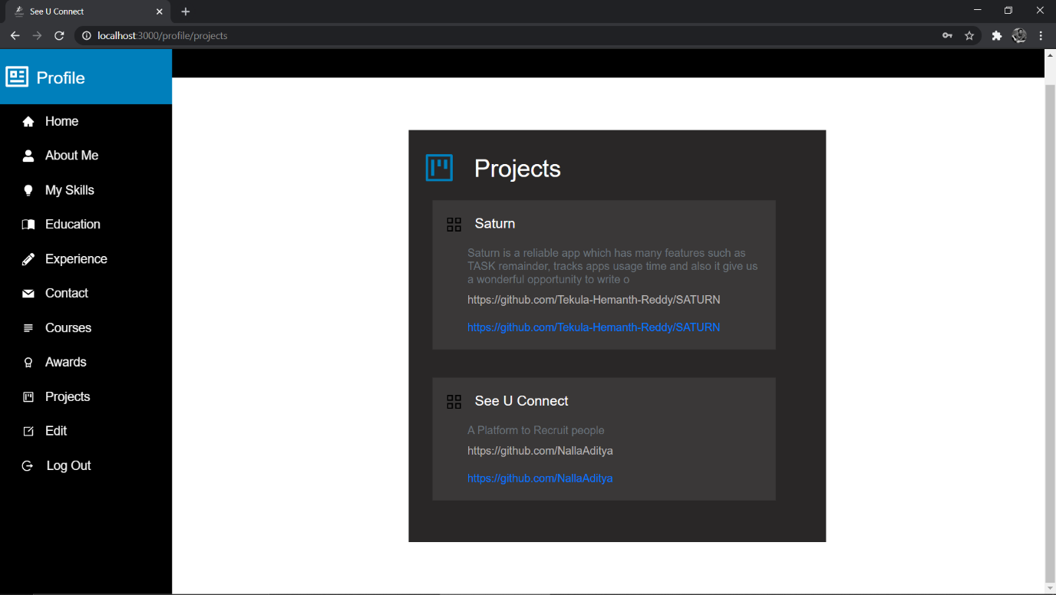

8.4.26 Projects Done by Student

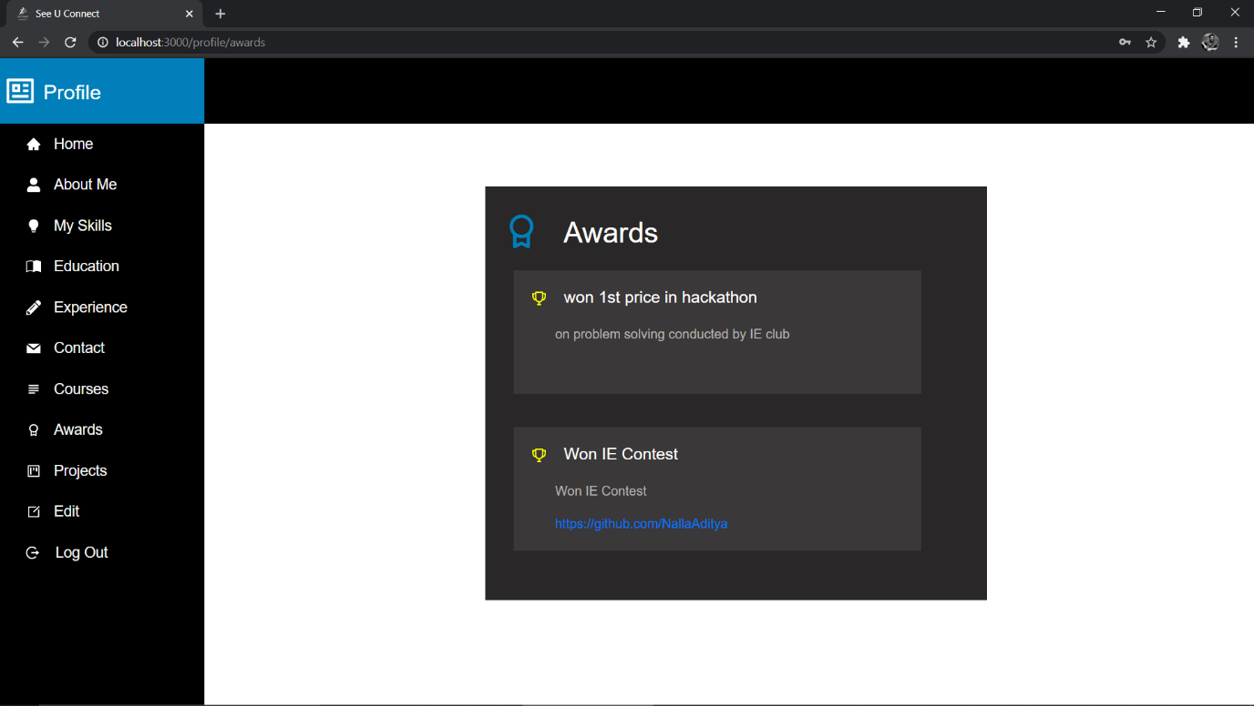

8.4.27 Awards won by Student

**9. Conclusion and Future Work** From this project we were able to bridge the gap between college Alumni, Recruiters and the students. Here it helps the students also find opportunities and know the market requirements. For the future work we want to collaborate the project with each college’s website and sync the college data with this so as the college can also store these data and also it helps recruiting done in broad scale. So in the next phase we can use Deep learning techniques in order to scrap data when a student uploads some documents and store the data and also use this data during the recruitment process.

## 10. References

1. <https://docs.atlas.mongodb.com/getting-started/>
2. <https://graphql.org/graphql-js/>
3. <https://reactjs.org/docs/getting-started.html>
4. <https://react-bootstrap.github.io/getting-started/introduction/>